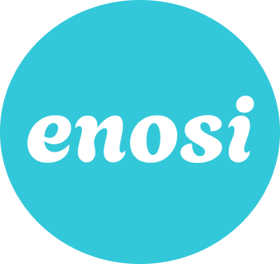

Table of Contents

Project name & value proposition 2
Team members' names and roles 2
Problem/Solution Overview 2
Needfinding 2
POVs & experience prototypes 4
Design evolution 9
Final solution 9
Tasks 10
Design evolution visualization(s) and rationale 20
Values in design 25
Final prototype implementation 26
Tools used; pros and cons of these tools 26
Wizard of Oz techniques 26
Hardcoded Techniques 26
Reflection & next steps 27

Project name & value proposition
Name: Enosi

About: Our platform is a community-focused platform designed for individuals undergoing lifestyle transitions. We prioritize physical and mental wellness by encouraging group-goal accomplishments, uniting people in their shared journey towards better well-being.

Our Mission Statement: A collective pursuit of well-being.

Name Origin: Derived from the Greek word, Enosis, which refers to the movement of communities that formed the modern political and social union of Greece

Value Prop: Leverage the power of community to motivate, inspire, and drive progress. No one goes through a lifestyle or wellbeing change alone.

Team members' names and roles
Elysia Smyers: Chief Technical Officer
B.S. Symbolic Systems, M.S. Computer Science

Fahad Nabi: Chief Product Officer
B.S. Symbolic Systems, M.S. Computer Science

Lyndsea Warkenthien: Chief Executive Officer
B.S. Computer Science

Problem/Solution Overview
Problem Space: Lifestyle transitions can often be lonely, causing feelings of isolation, discouragement, and a sense of being overwhelmed.

Solution Space: By setting shared goals, members can motivate and push each other forward, creating a snowball effect of positivity and progress.

Needfinding
Our needfinding methodology was to build rapport, seek stories, ask the right questions, and follow up on interesting points that exhibited depth.

We talked to three people who were experiencing lifestyle transitions in distinct ways: Nick (New Environment), Uba (New Parent), and Hannah (New Chapter). Key Insights:

Nick: “I just log [physical activities] out of routine, and they’re more like nice things to look at. I find functionally, they don’t encourage me to take further action, and lack the contextualization of other aspects of my life, like changes in my environment.”

Ubai: “I went from an active lifestyle to a more reactive lifestyle.”

Hannah: “I am trying to explore different ways to socialize and make friends in a new city and environment that I do not have a support network in, especially over activities that do not necessarily break the bank.”

Empathy Map For Hannah:
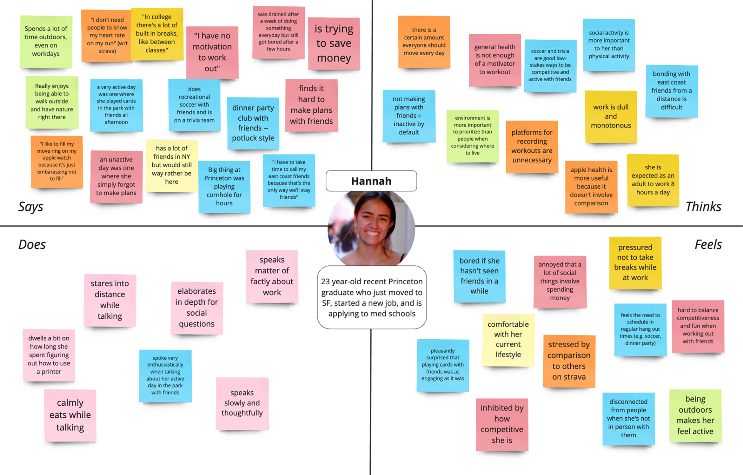

Understanding Hannah’s Nits and Needs:
Insight: Younger people have less of a pressing motivation to stay physically active, so social activity often takes precedence.
Need: Young adults need ways to stay physically active that also leverage the appeal of social activity. Young adults need ways to connect with friends that do not involve spending money.

Insight: For some, platforms like Strava do more harm than good because people feel pressured to constantly compare themselves to others.
Need: Young adults need a way to balance competitiveness and enjoyment in physical activities.

Insight: People often feel mentally drained by the idea that they are obligated to work all day in adult life.
Need: People need a way to feel more mentally distanced from work when taking breaks during the work day.

Summarizing Insights:
- Transition requires specialized support and resources to adjust routines and responsibilities, dependent on personal and professional responsibilities
- Sustainable long-term physical activity goals should be tailored to individual habits
- Social influence plays a role in one's physical activity patterns

POVs & experience prototypes

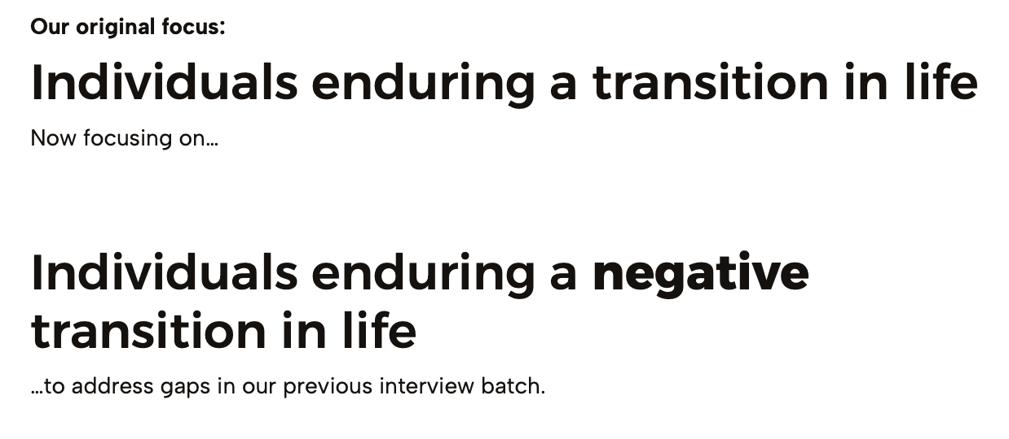
POV 1: Carla
We met Carla, an older adult who loves games and has gone through a difficult life change through the loss of her husband of 40 years. She is now redefining what an active lifestyle means to her. We were surprised to learn that her motivation for staying active fluctuates greatly depending on her mood, but feels more energized for activities that include games. We wonder if this means Carla would be more motivated to engage in activities that she used to love if she could be externally rewarded in some way by engaging. It would be game-changing to help motivate Carla to stay consistently active by tapping into her prior love for games.

HMWs: Carla
How might we gamify activity in a way that is not overwhelmingly competitive?
How might we bridge the gap between physical and social activities and blend them into holistic experiences?
How might we turn daily chores or tasks into fun, interactive forms of physical activity?

POV 2: Ubai
We met Ubai, a new parent who has struggled to maintain an active lifestyle. We were surprised to learn that Ubai’s life view changed entirely when the new baby arrived, turning into the view that his top priority was to keep his baby alive. We wonder if this means that Ubai feels like he has lost control of his life and therefore his ability to do active things for himself. It would be game-changing for new parents to be able to bond over physical activity that involves simultaneous care of their babies, creating an opportunity for both social and physical activity.

HMWs: Ubai
How might we incorporate “little wins” of physical activity into the day-to-day responsibilities of a parent?
How might we empower new parents by achieving fitness goals in a way that scales with where they are in parenthood?
How might we help new parents triage their caretaking responsibilities who need more free time for self-care?

POV 3: Kiran
We met Kiran, an active young adult who recently graduated university and is taking time off to apply to Med School while living at home with his family. We were surprised to learn that Kiran did not have the same relationship he had with soccer before and after his Achilles Tear injury. We wonder if this means that injuries fundamentally change mindsets around competition and core priorities. It would be game changing if support systems and communities can help athletes persevere through mental and emotional turmoil of recovery.

HMWs: Kiran
How might we incorporate mental wellness into physical therapy?
How might we rebuild lost trust athletes have throughout their recovery process?
How might we help athletes feel like they are making progress in recovery with the support of their own professional, family, and friends?

Top 3 HMWs
- How might we incorporate fun, interactive forms of physical activity into daily tasks?
- How might we empower new parents with fitness goals that are “little wins” that scale as they progress through parenthood?
- How might we gamify physical activity in a way that is social without being overwhelmingly competitive?

Experience Prototype 1
Solution Idea: Task-tracking app that makes recommendations for physical activity that can be incorporated into your schedule, like stretching after every few tasks or walking to the grocery store instead of driving if you have time

Assumption: People will integrate recommendations of physical activity into their schedule from an application where they must import their current schedule

UX Prototype: Testing the decision path of people who take action from a recommendation.

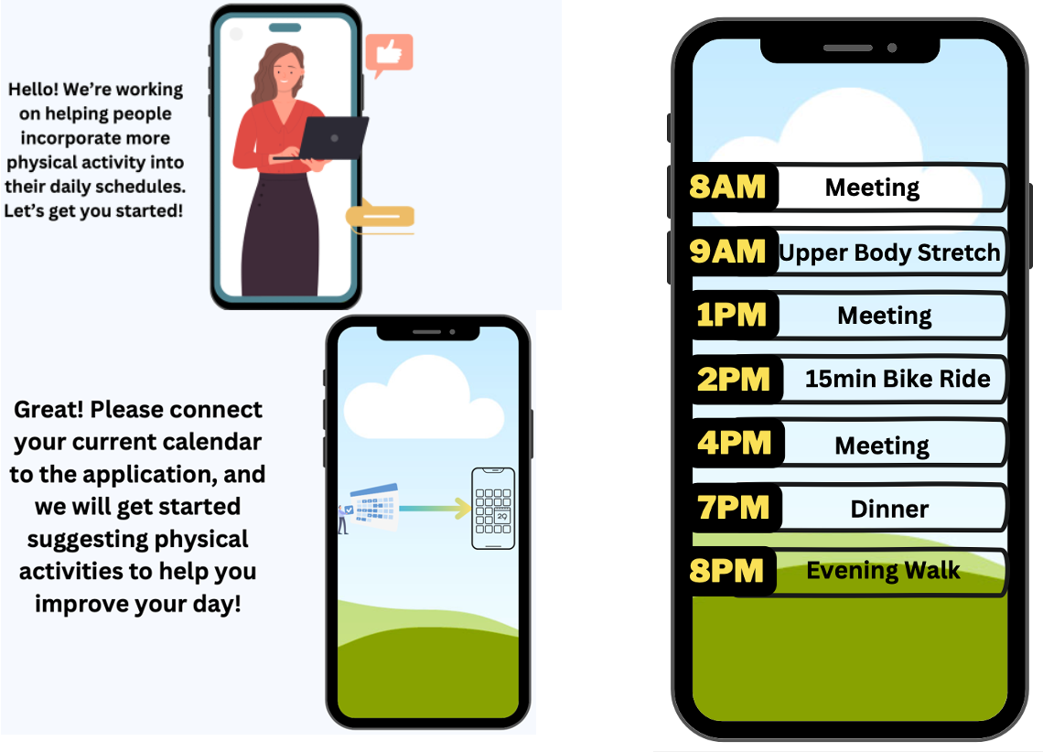

Result: No-Go
- Reminders to do simple things like stretching or walking around could be useful
- Importing schedule is easy if straightforward, but complications might arise with secure calendars
- “Breaks” will vary in ability to actually take a break
- More logical solution could be to schedule blocks in your calendar during the day, for which an extra app would be overhead

Experience Prototype 2
Solution Idea: Creating a social feed focused on sharing experiences with friends: users log physical activity details (i.e., hikes, runs, dance classes) and tag specific friends / locations.

Assumption: There is motivation or incentive to share physical acts.

UX Prototype: Testing whether people are influenced by others’ when making the decisions to post on social feeds.
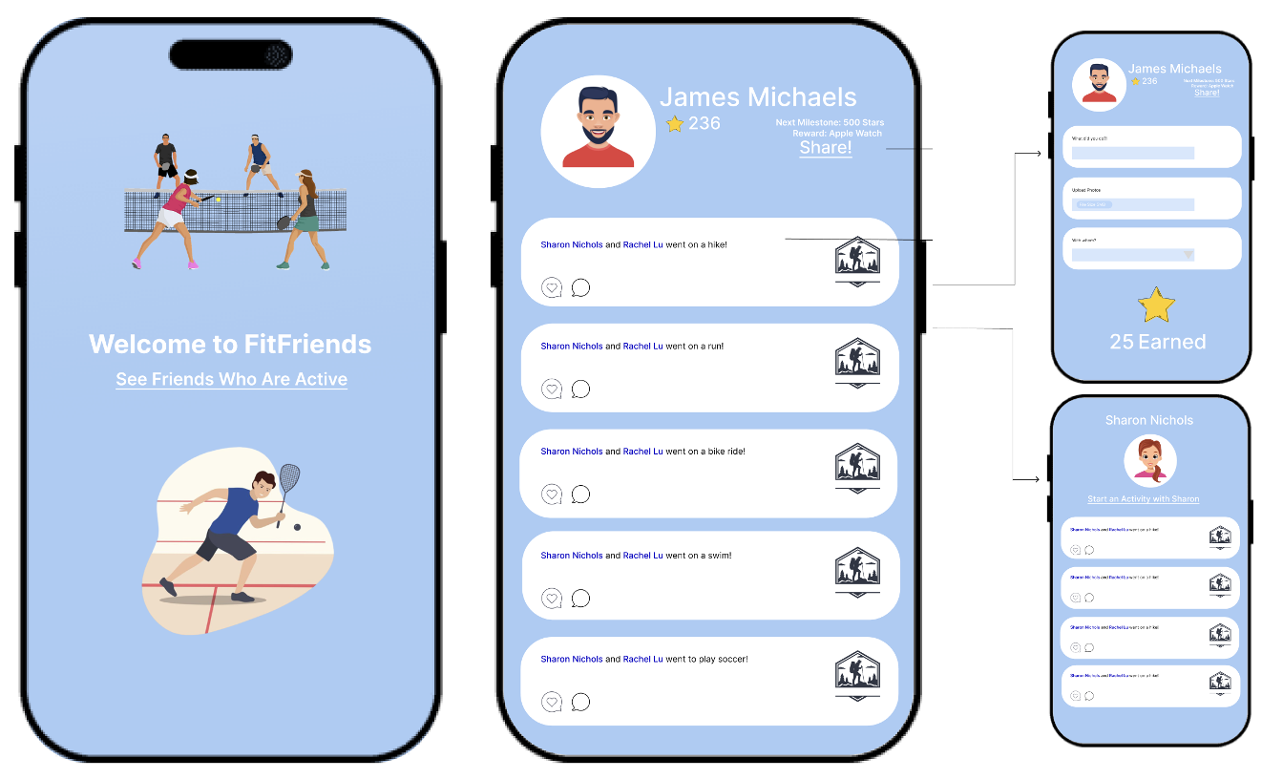

Result: No Go. Positive feedback loop of social accountability: Emily is motivated to work out and share activities when she sees friends doing so. Emily would be most inclined to share if close friends were engaged on the platform.

Experience Prototype 3
Solution Idea: Using a group of your choosing together you will complete physical, social, or mental well-being tasks each week to improve your lives and social bonds.

Assumption: Group fitness incentives are motivating and enjoyable for groups of friends.

UX Prototype: Testing group-based dynamics while completing individual performance goals and physical activity.
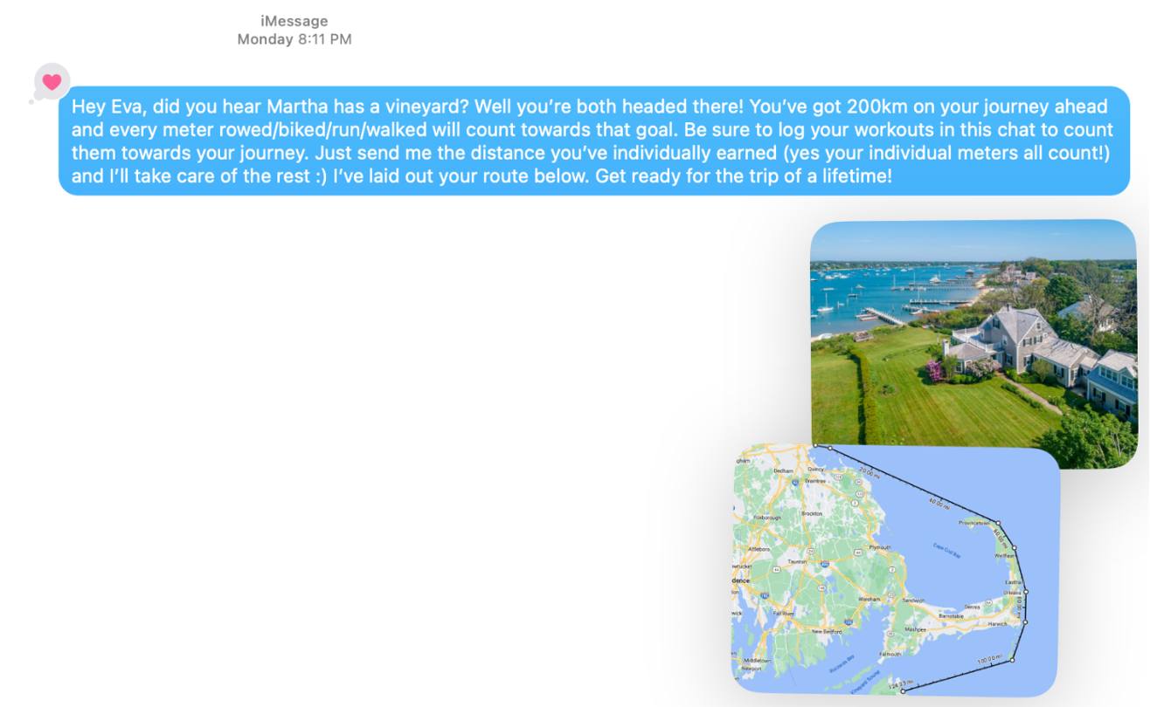
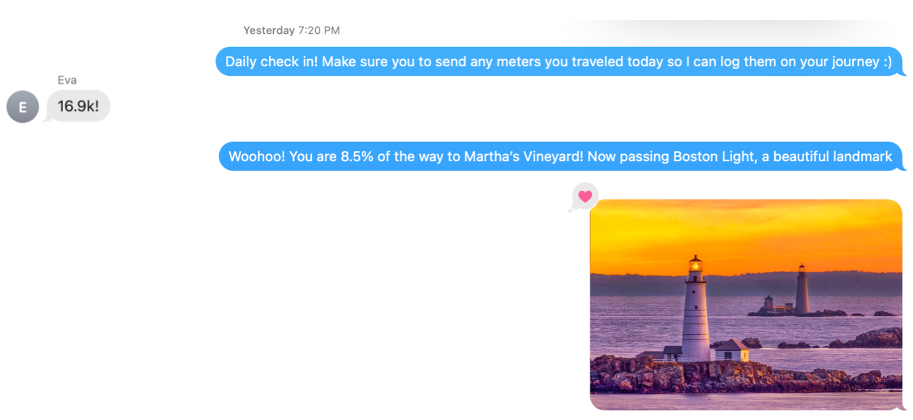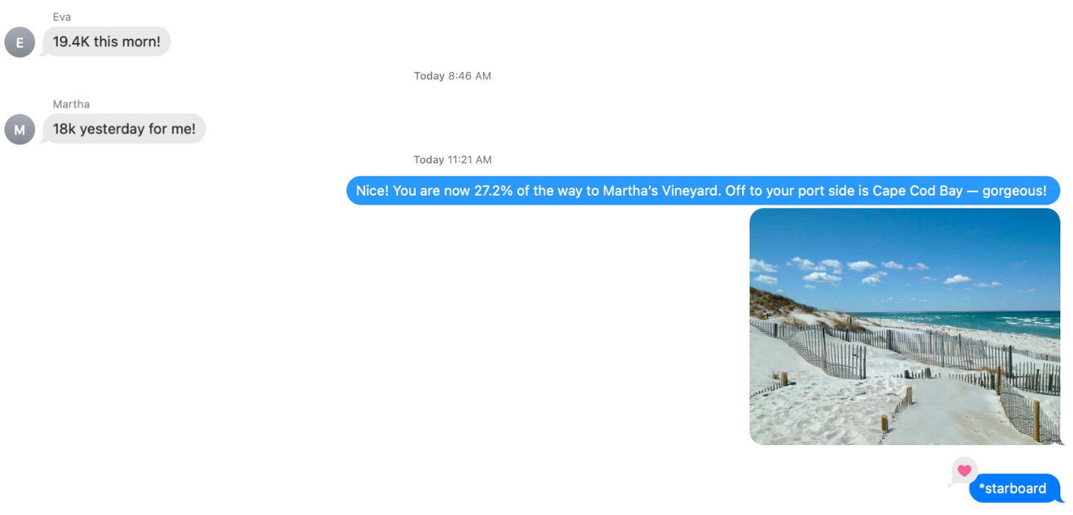
Result: Go. Participants viewed it as fun, they liked the picture updates. Finds the concept of a group goal motivating, maybe even more so if the emphasis was on minutes. Key insights uncovered from the interview include to make it easier to interpret the goal quickly (i.e., short messaging, quick button responses), properly scope distance goals (i.e., not reaching the goal was demotivating), and to make messaging clear that it’s a group goal.

Design evolution

Final solution

Our final solution is a mobile application that enables users to log physical activities, share their performances, and complete activity challenges with friends. Our differentiator is the fact that we allow users to create or join social groups based on a shared lifestyle transition; bringing people together and having strangers become friends based on a shared interest or experience and their desire for physical and mental wellness. We chose a mobile application to deliver our product, after conducting a tradeoff analysis with alternatives such as physical wearables, speech, and AR/VR. Narrowing it down to wearable devices vs mobile apps:

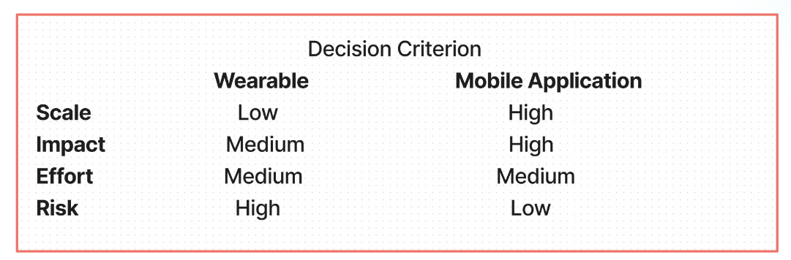

Although the wearable device would be a unique solution in our problem-space, the mobile application won because it is much easier to scale on cross-platform devices, provides people with the power to build greater communities and support networks and it is more accessible (i.e., fewer people have the means to afford a wearable device) , and requires less engineering effort as the application version can be continuously updated/launched to address tweaks.

We hope to measure the success of our product based on the following usability goals and measurements:
- Fun (scale 1-5): Does the participant have fun signing the guest book?
- Learnability (minutes/seconds): Is it faster the second time logging activities?
- Efficient (scale 1-5): How easy is it for the task to be completed?

Key tasks and initial sketches
Lo-Fi Prototype

High-Level Overview

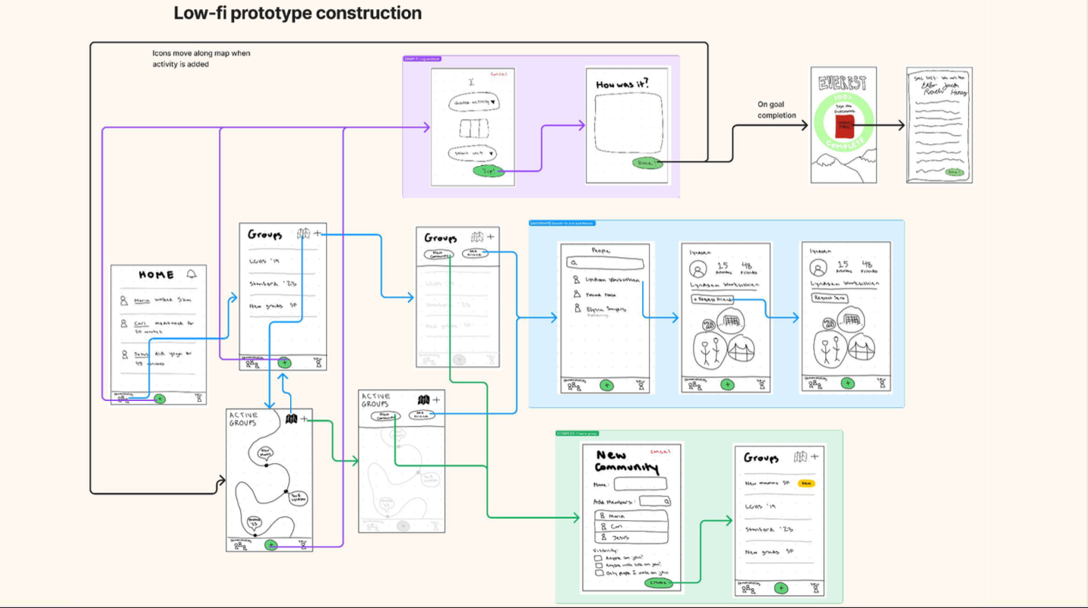

Simple Task: Log a Workout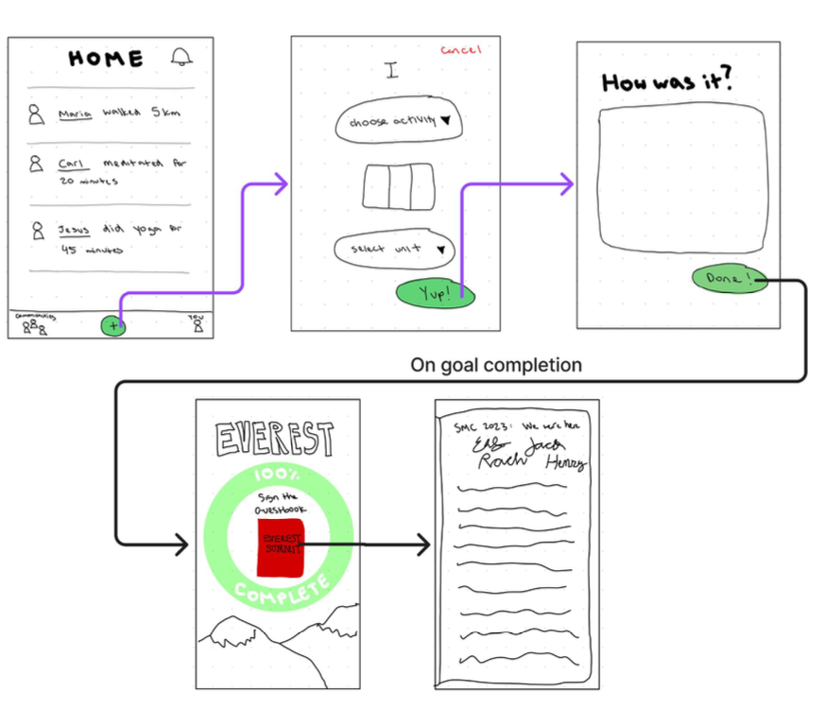
Medium Task: Search for and add a friend

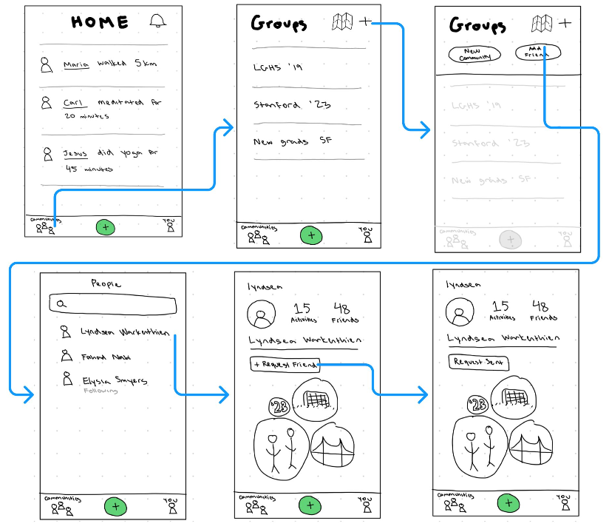

Complex Task: Create a group

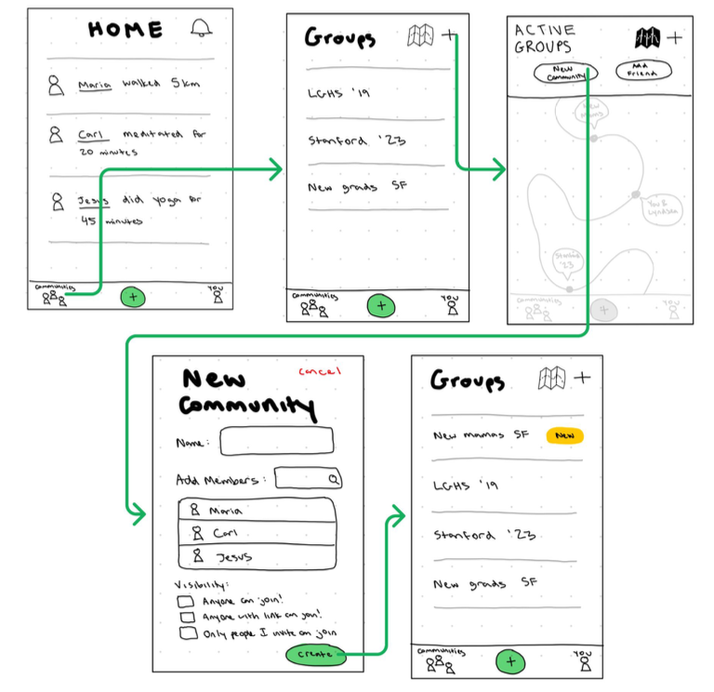
Med-Fi Prototype

Simple Task: Log a Workout
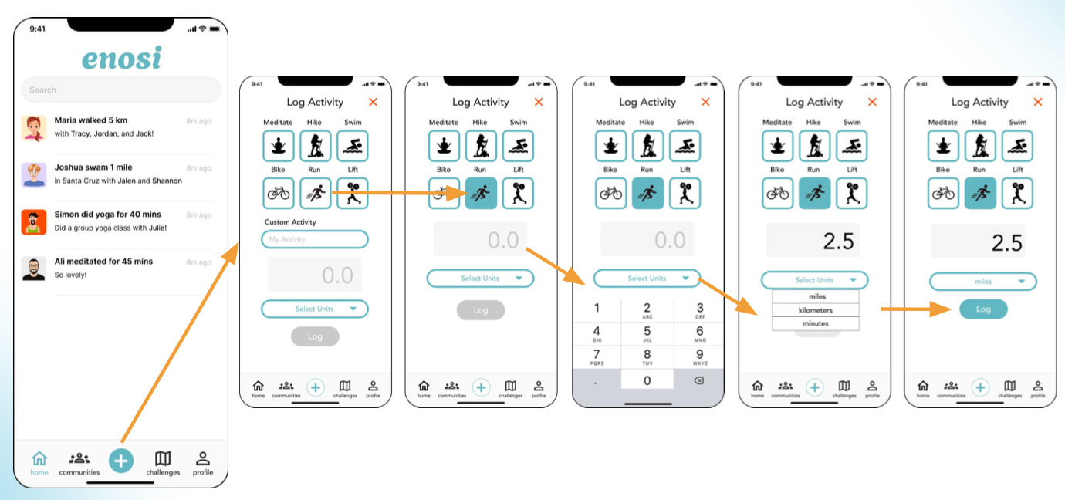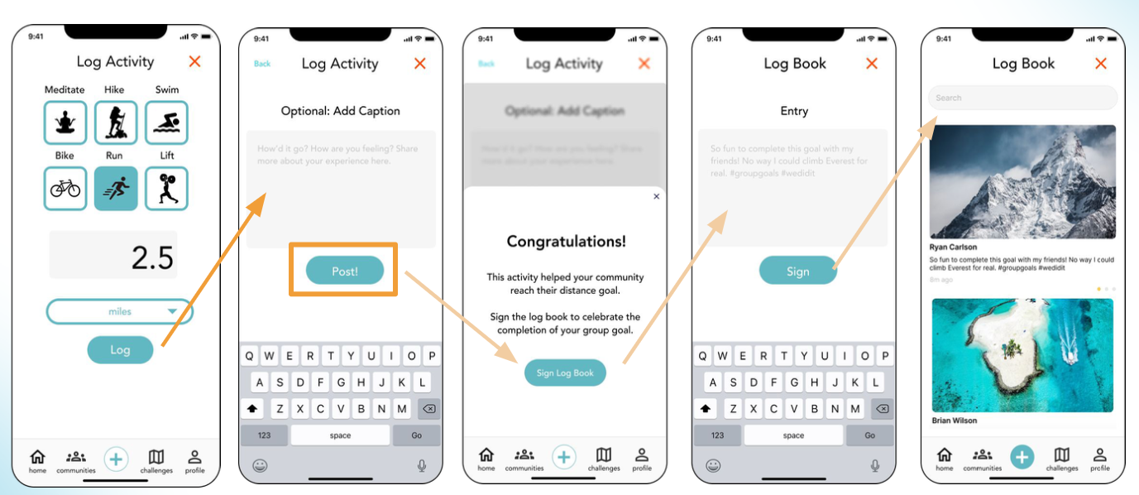

Medium Task: Search for and add a friend
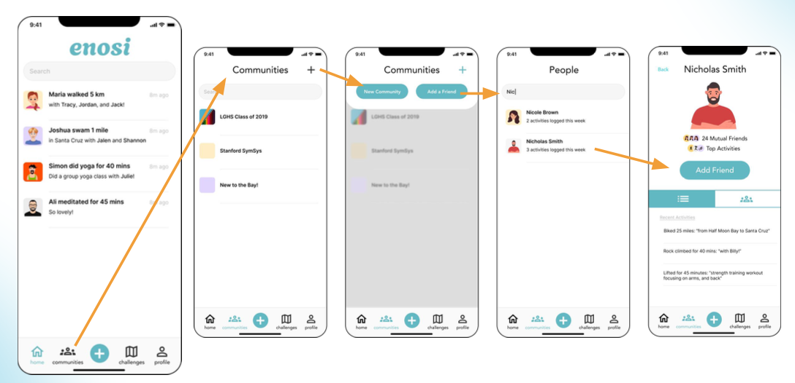

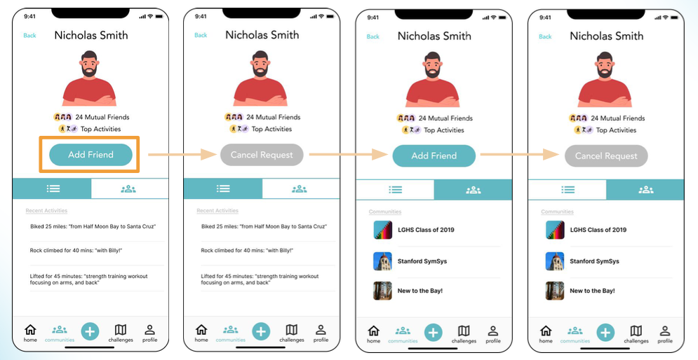

Complex Task: Create a group 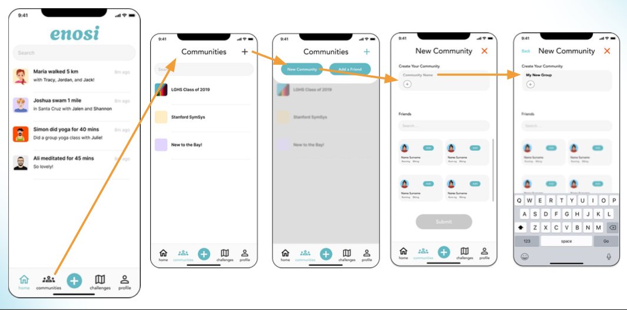

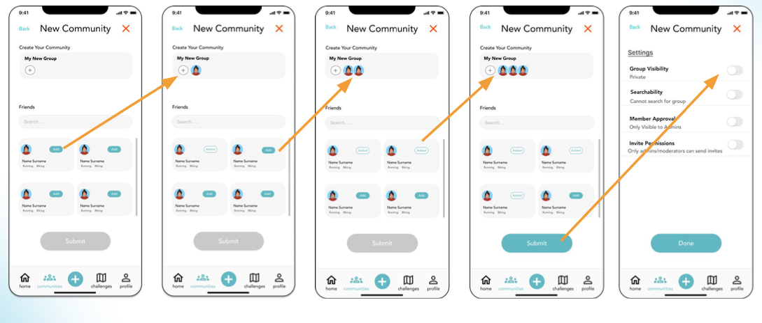

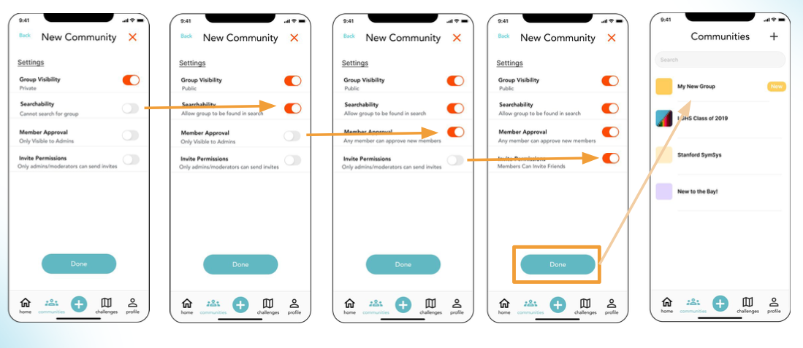

Hi-Fi Prototype

Home
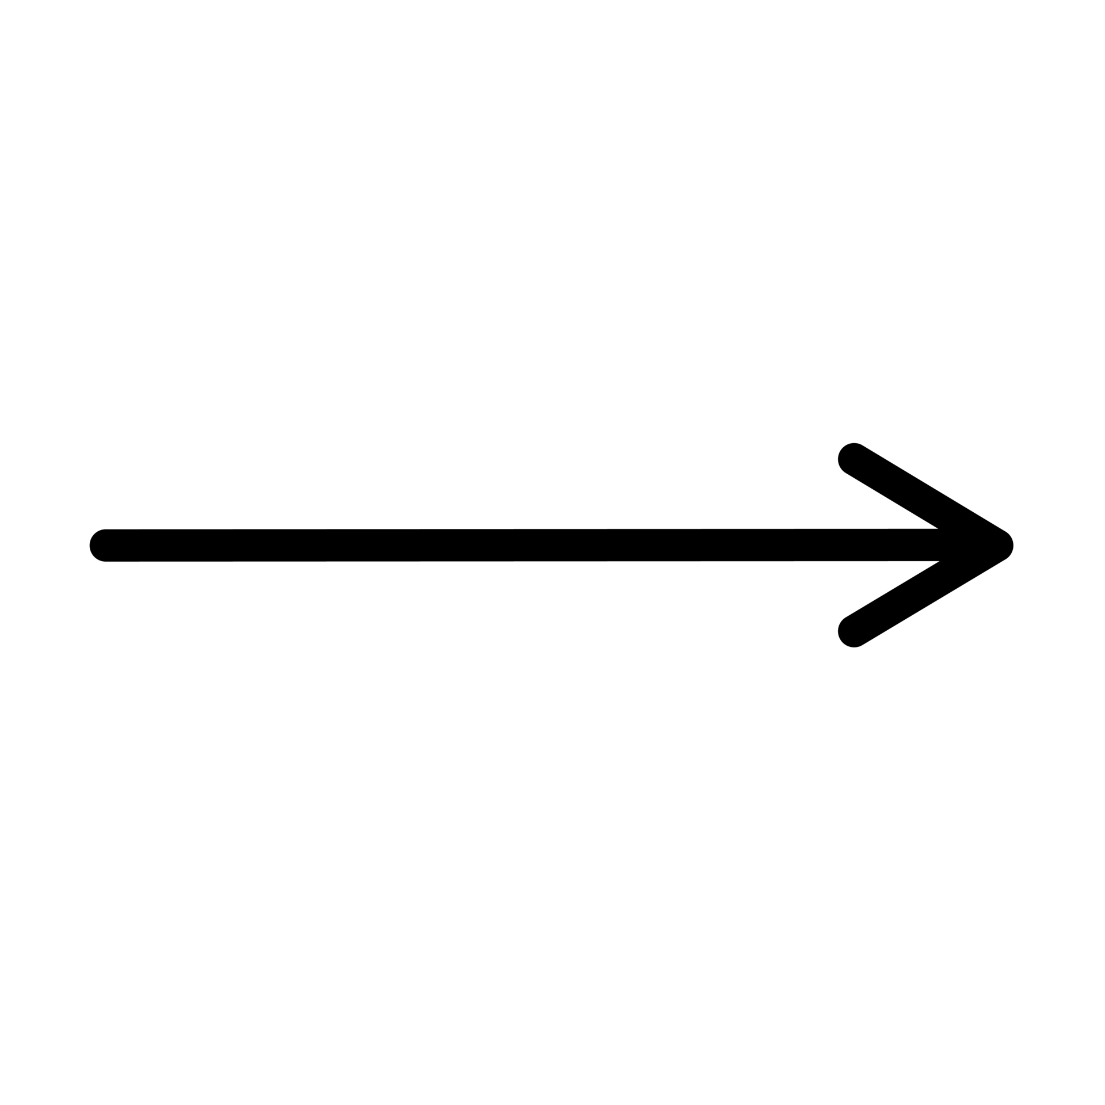
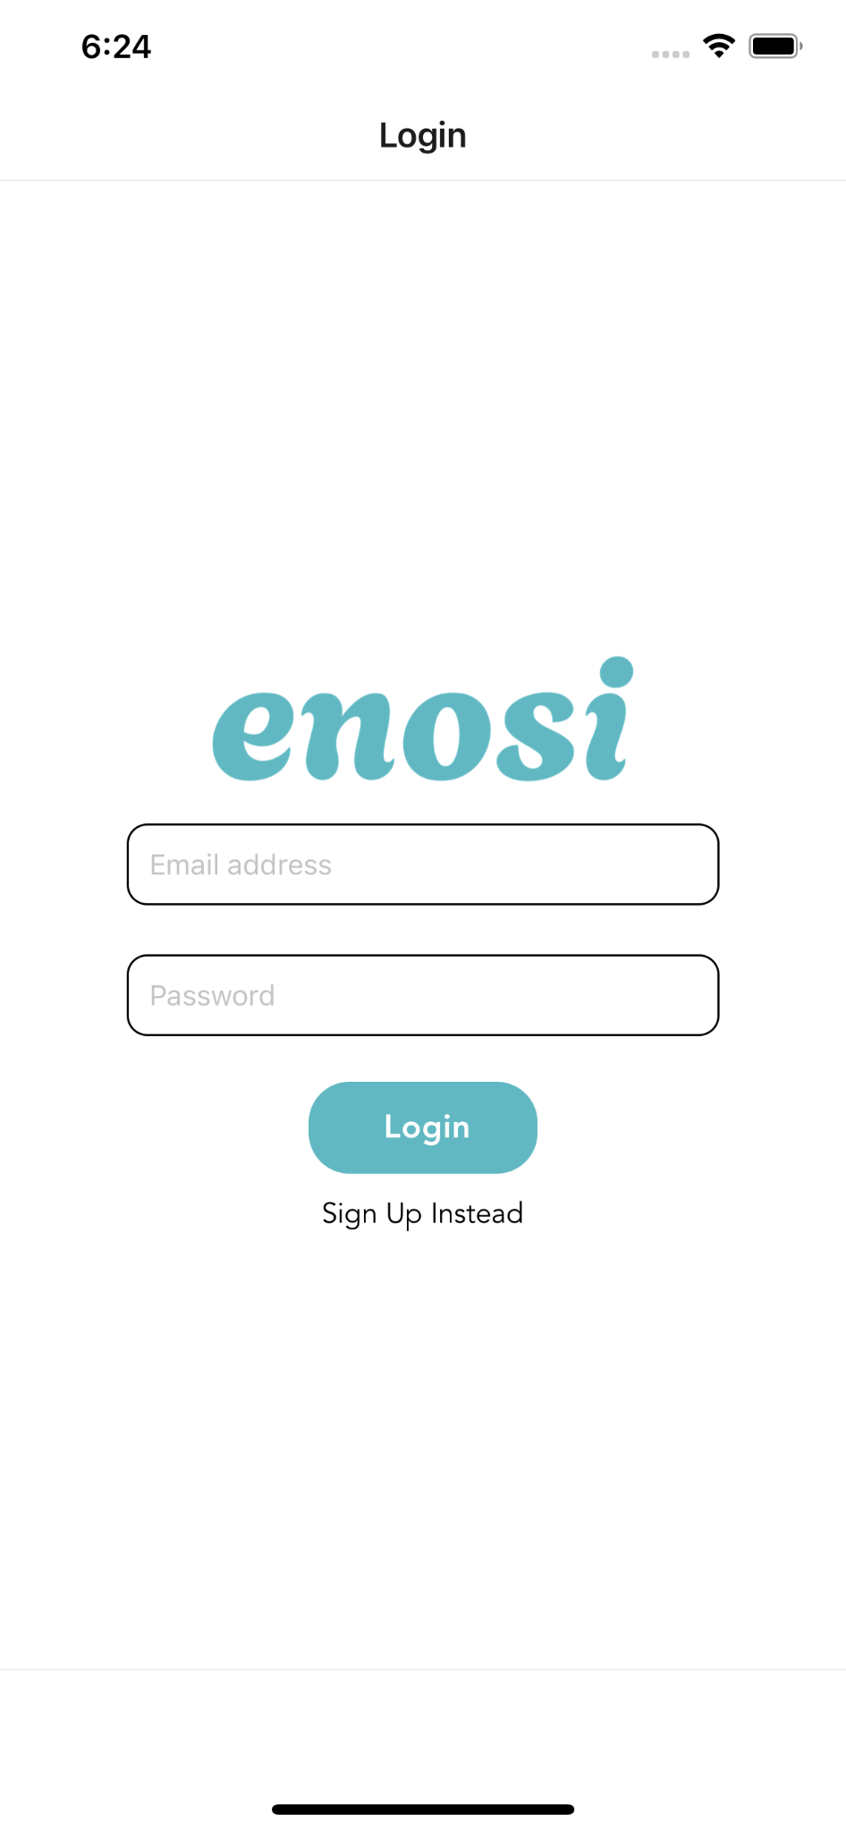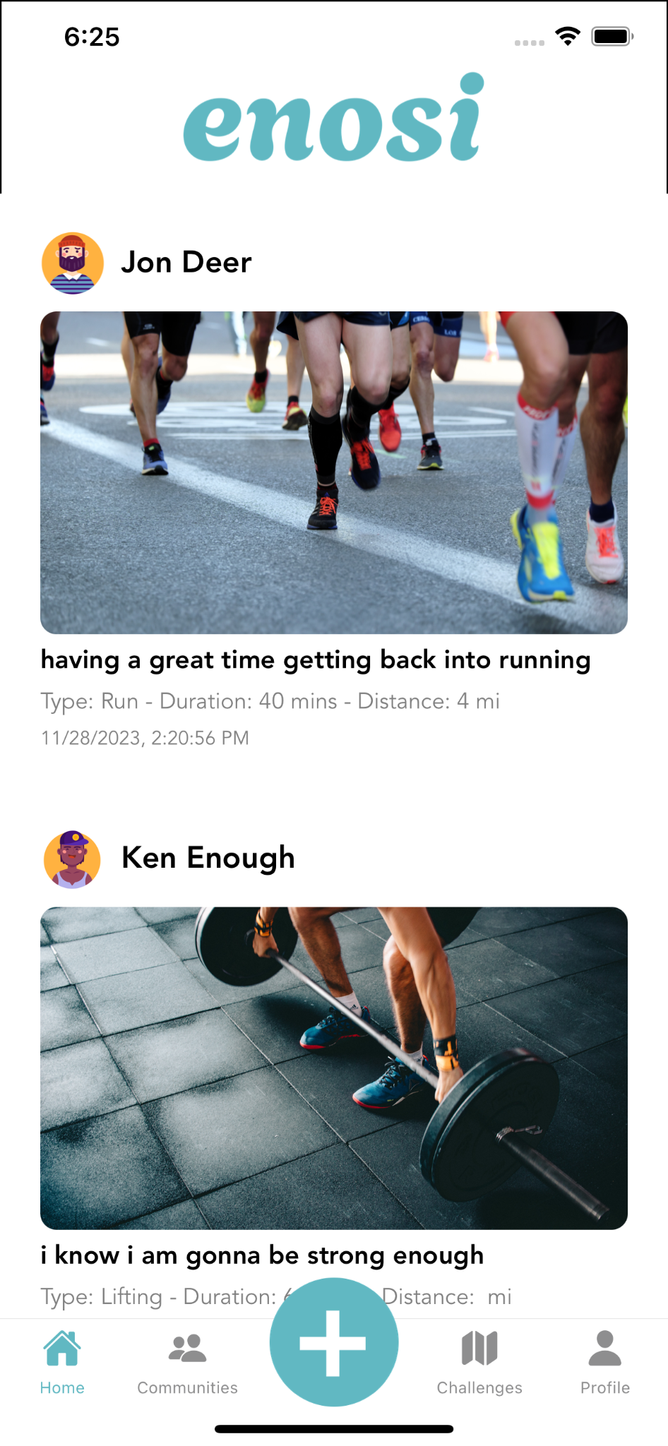

Simple Task: Log a Workout

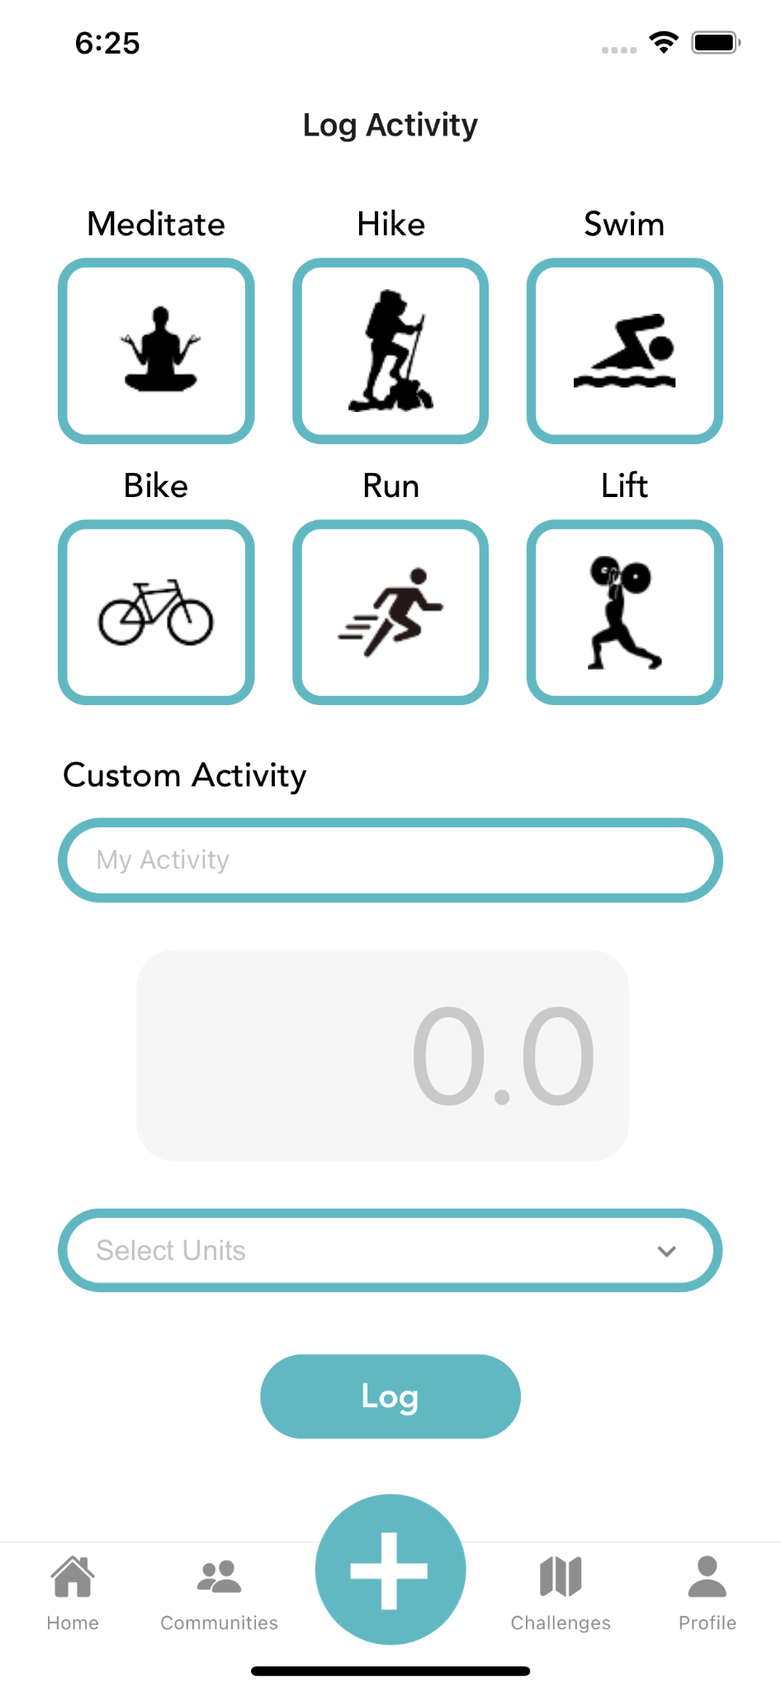 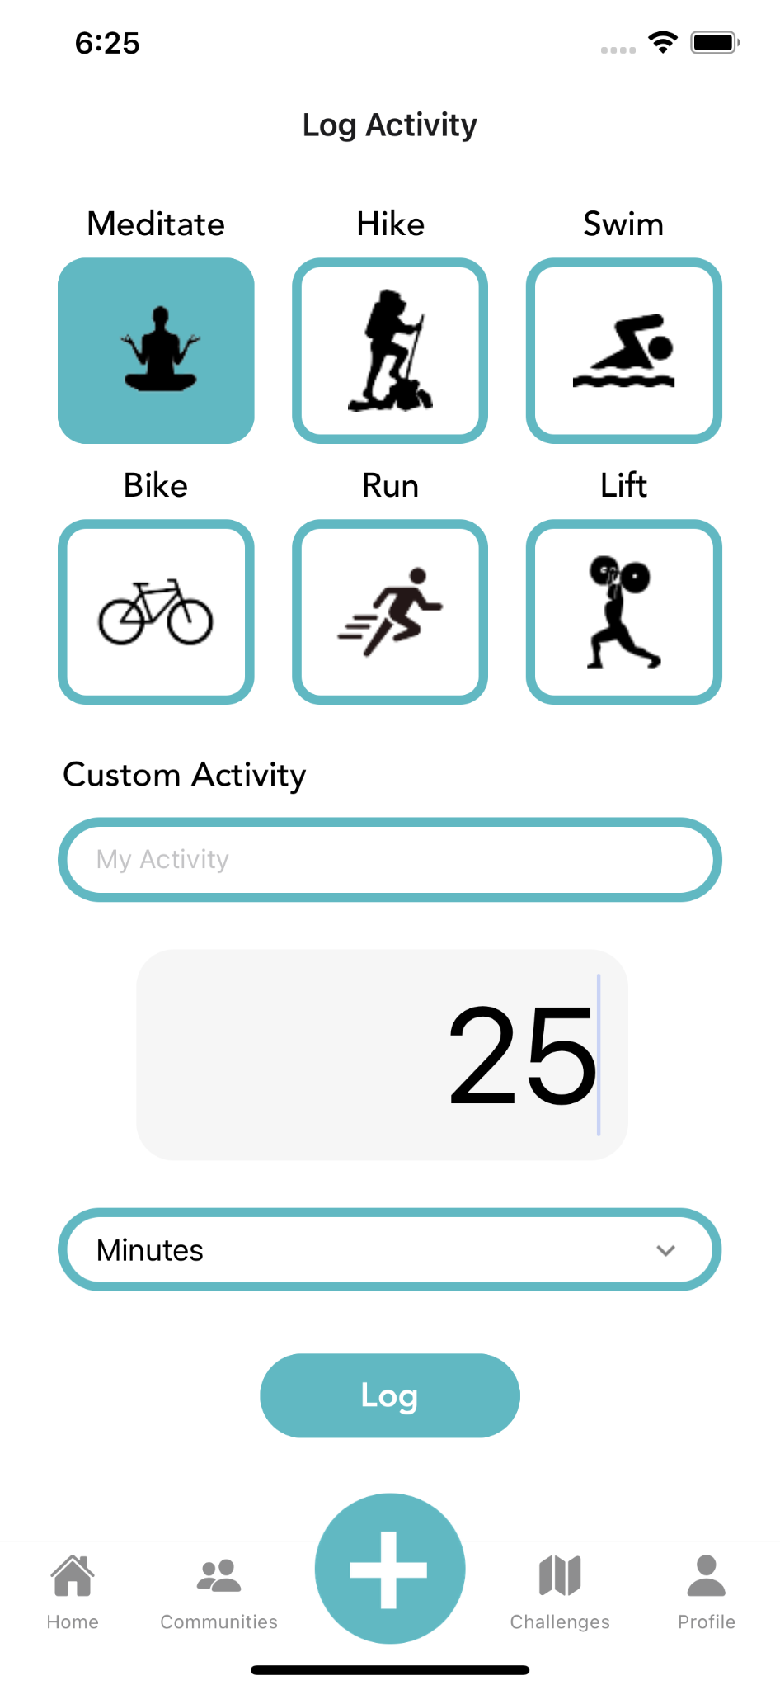 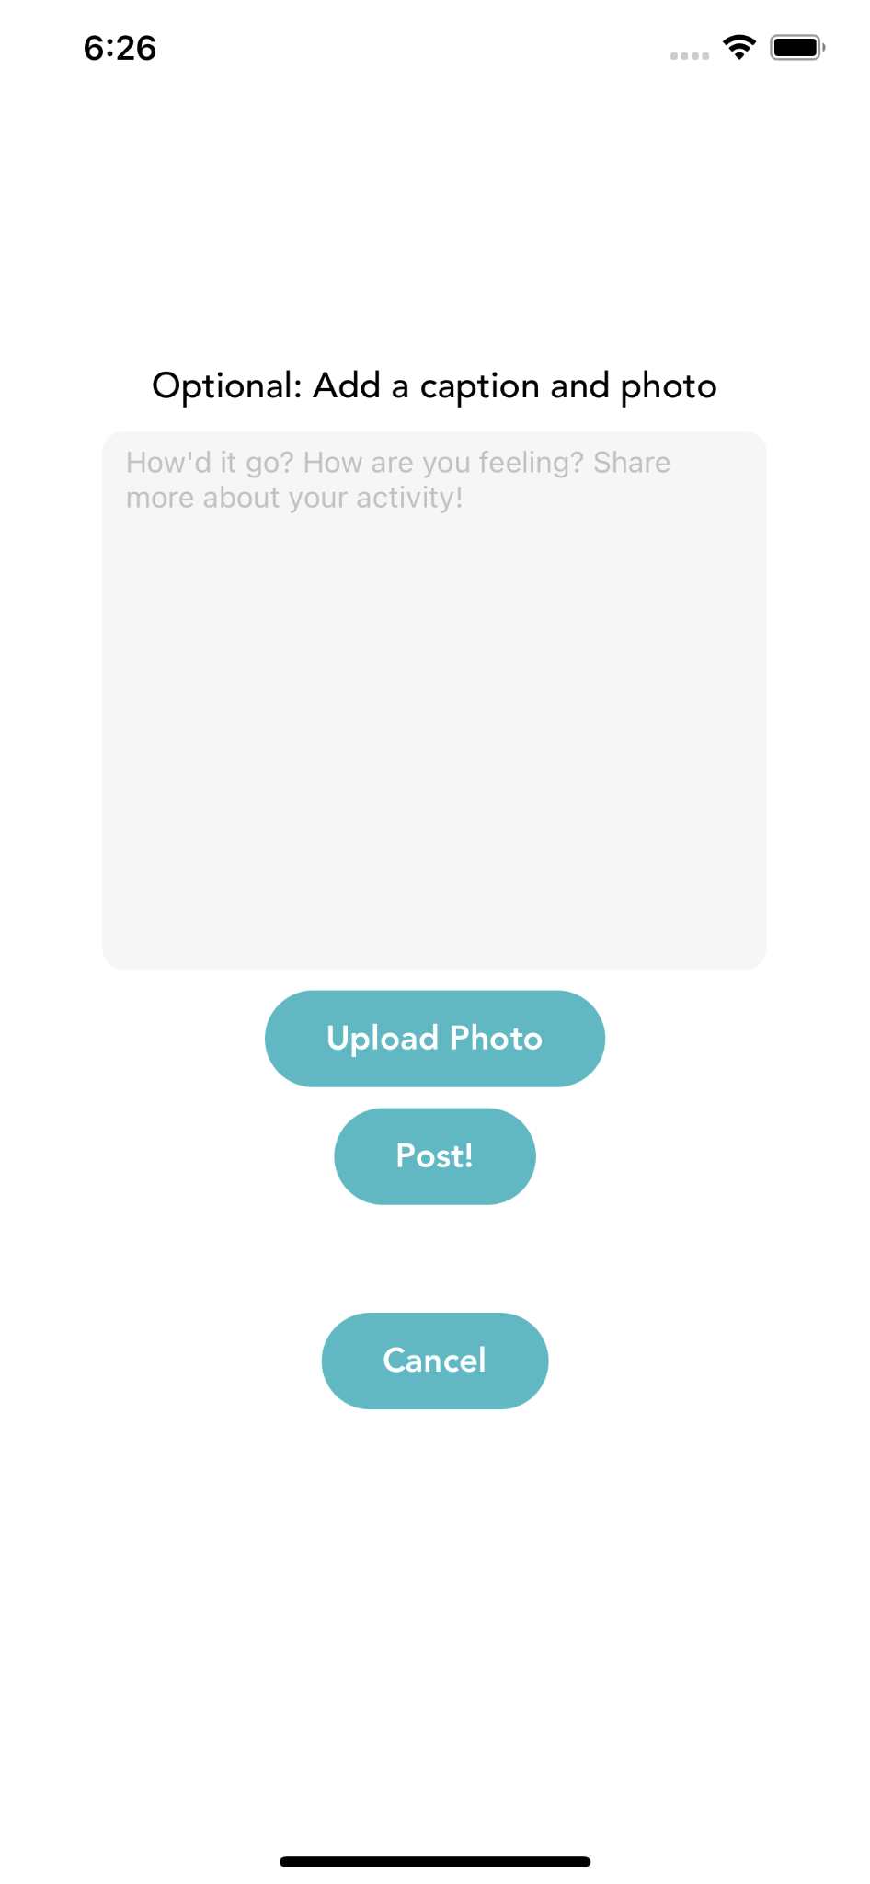]

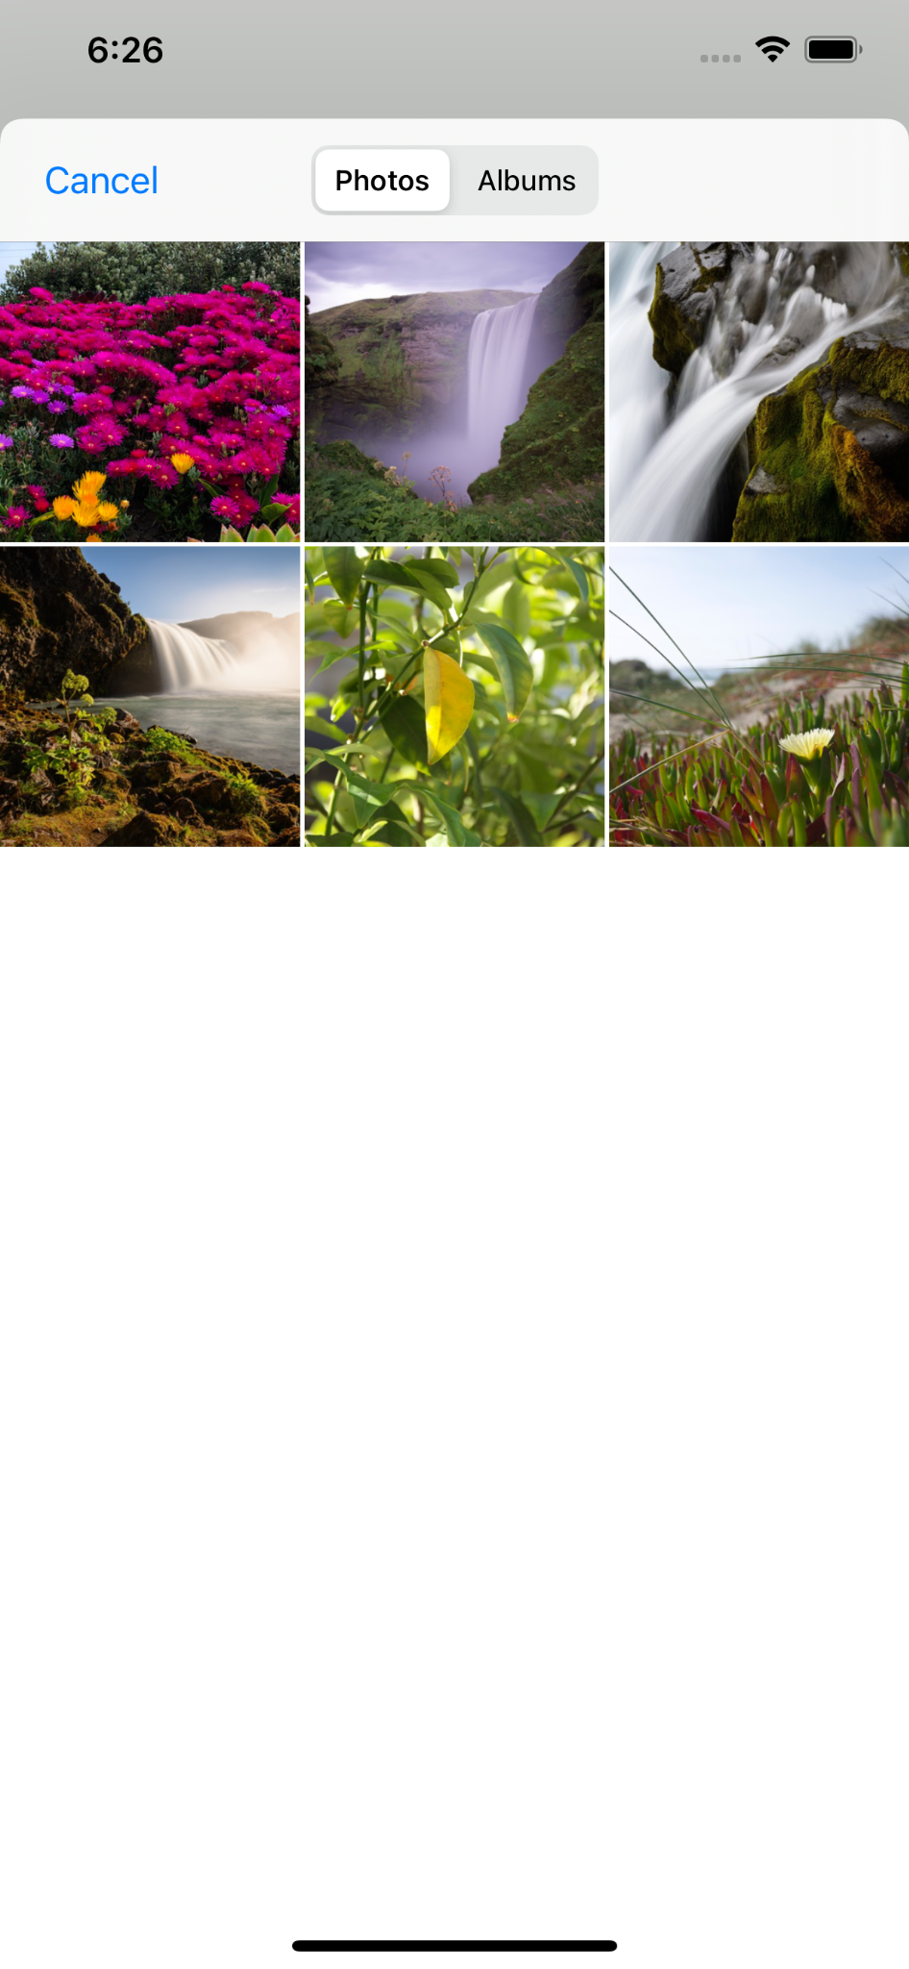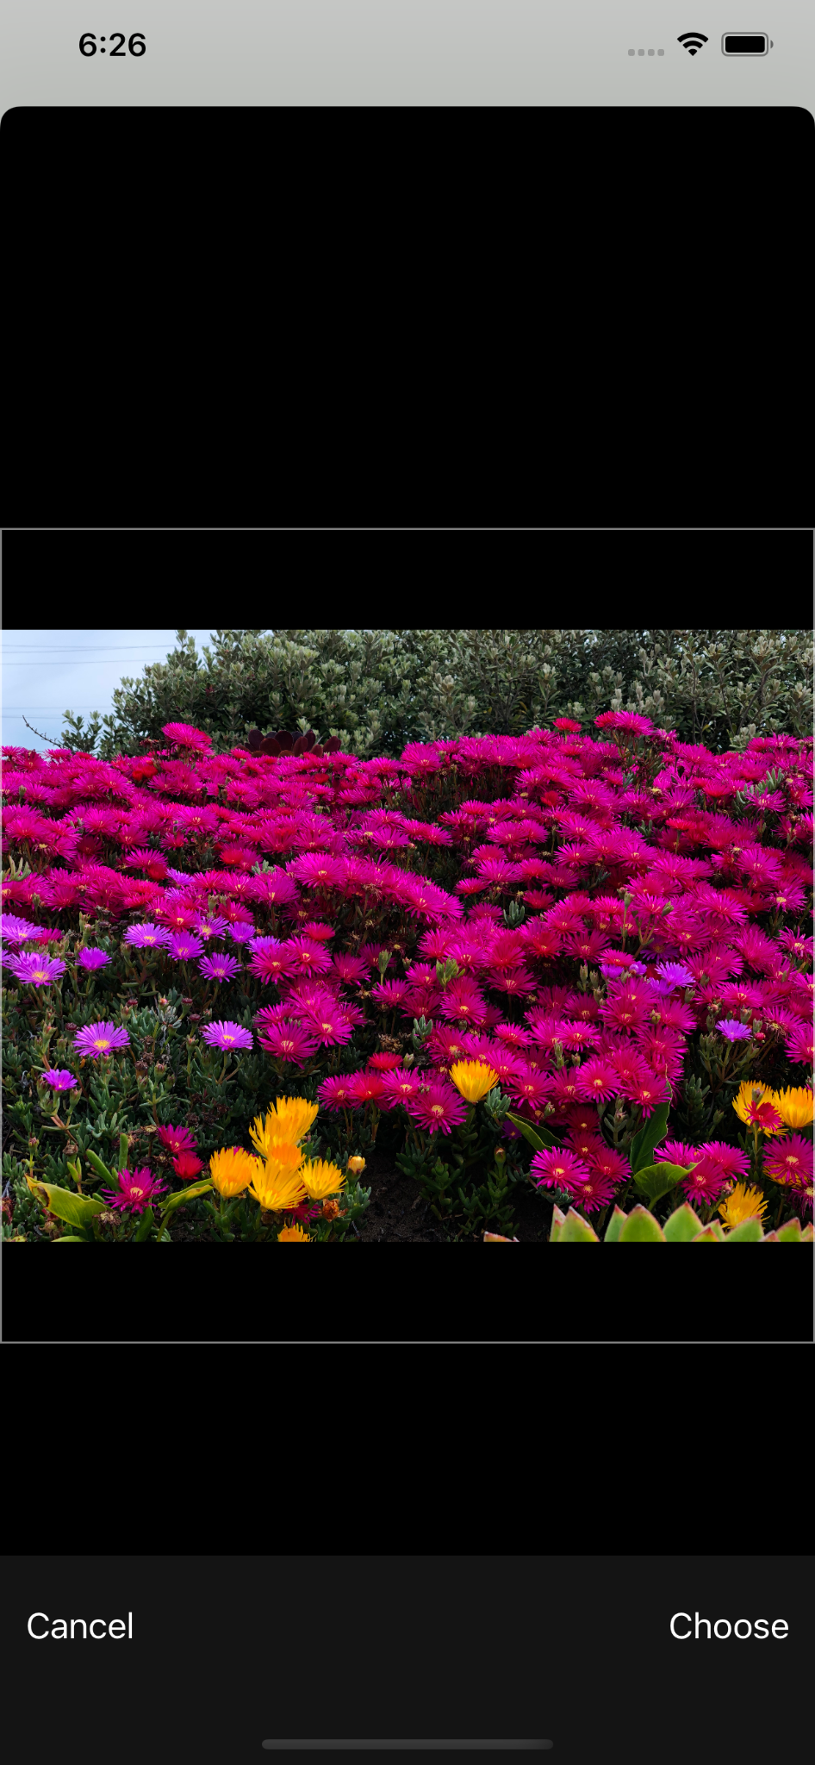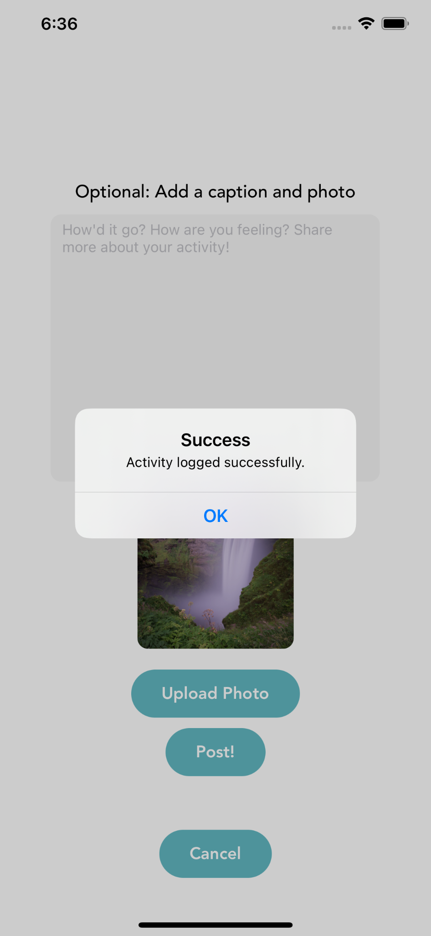
Medium Task: Search for and add a friend
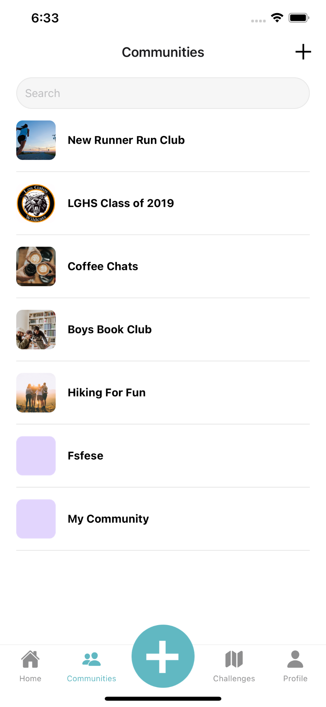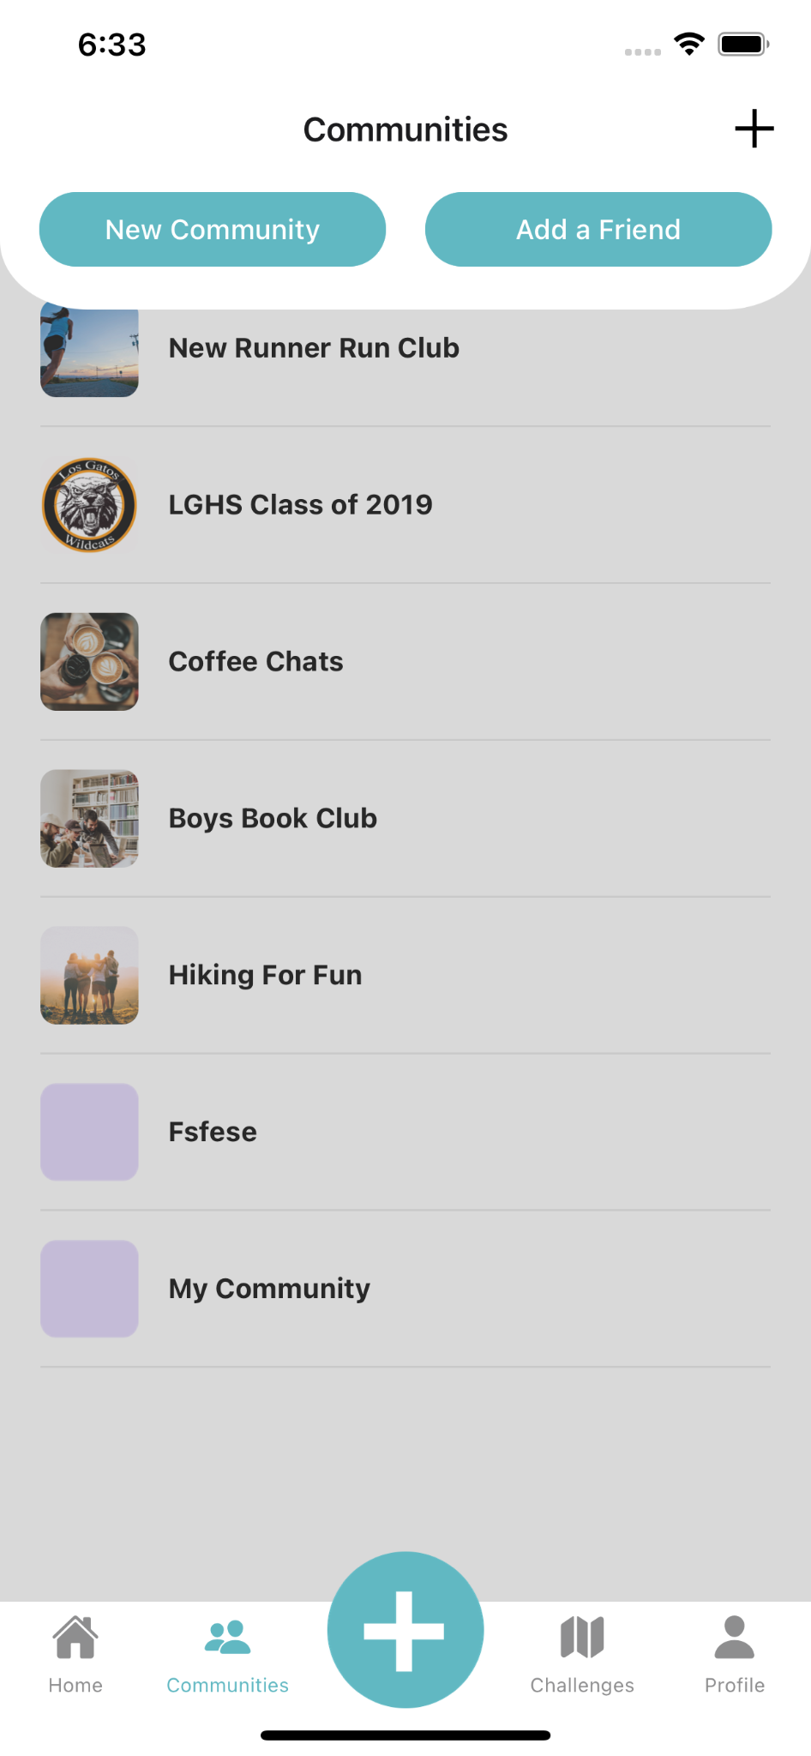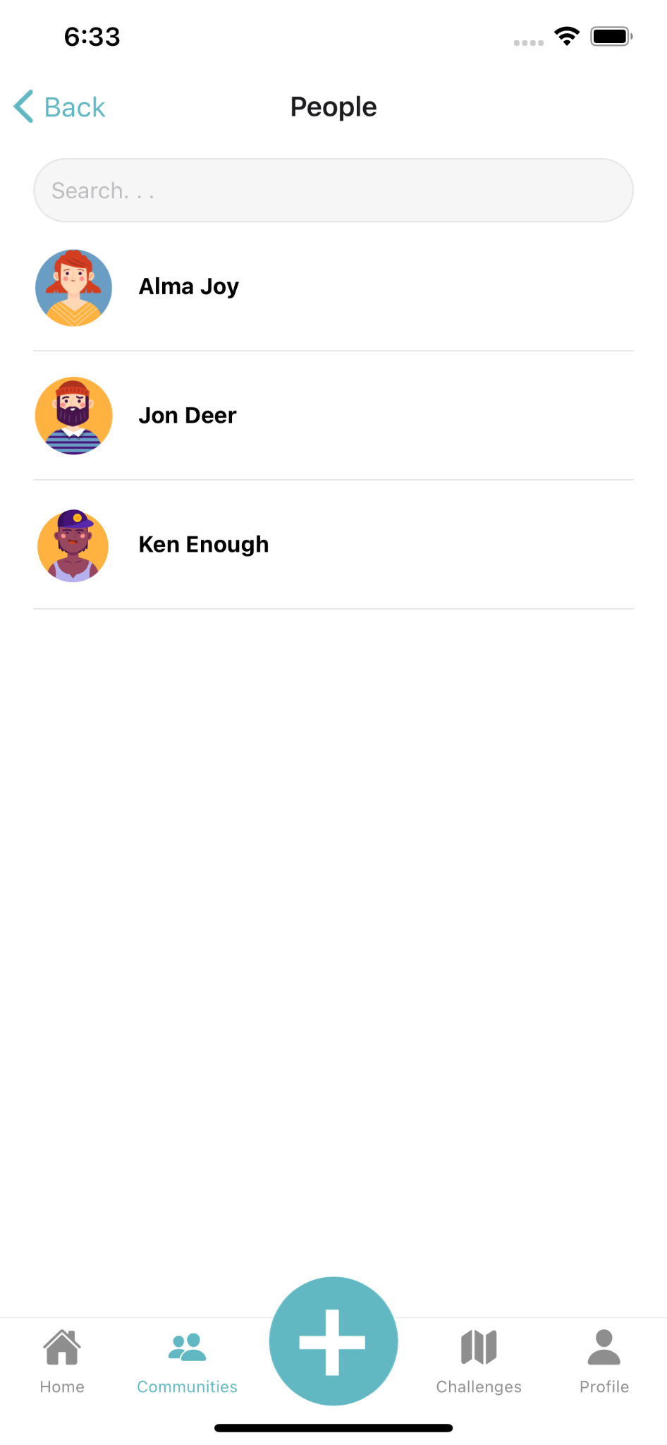

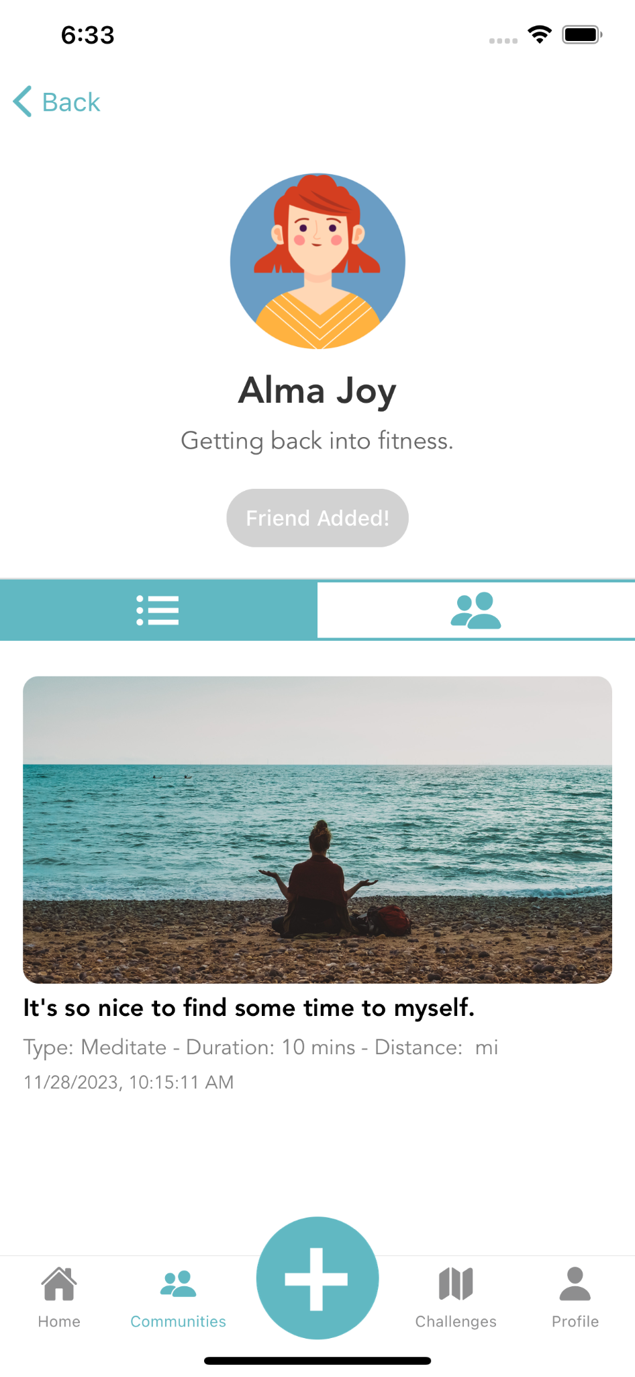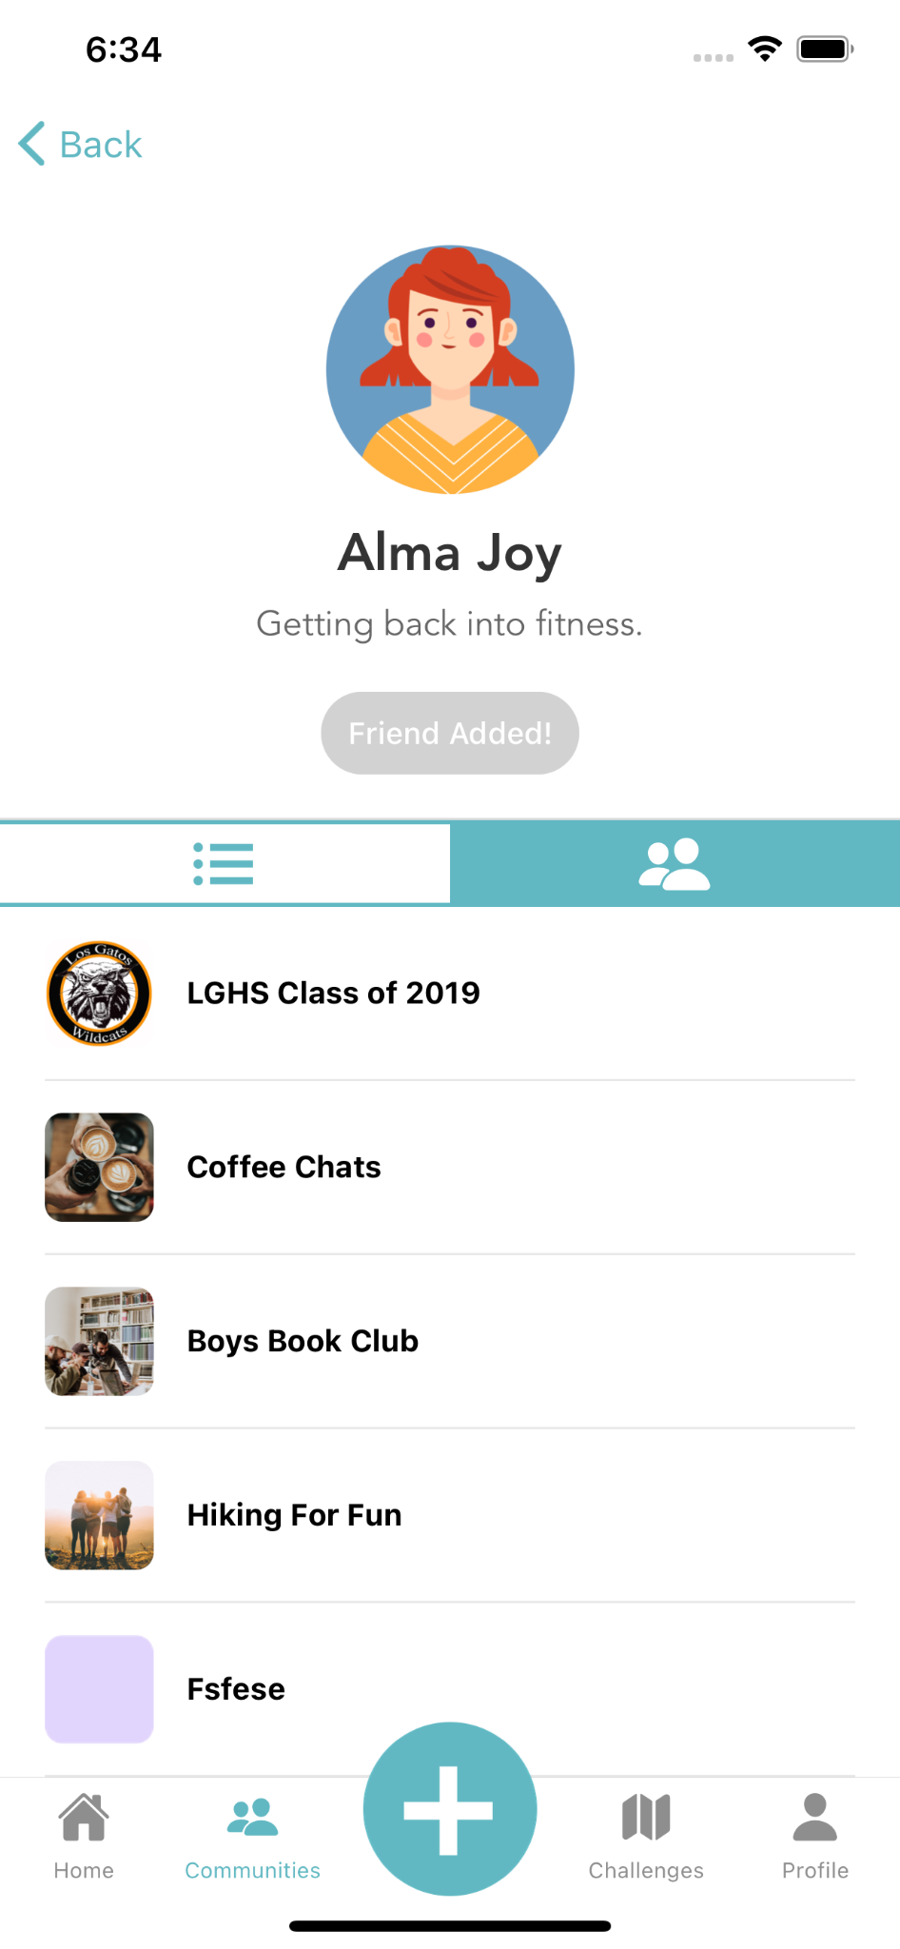

Complex Task: Create a group

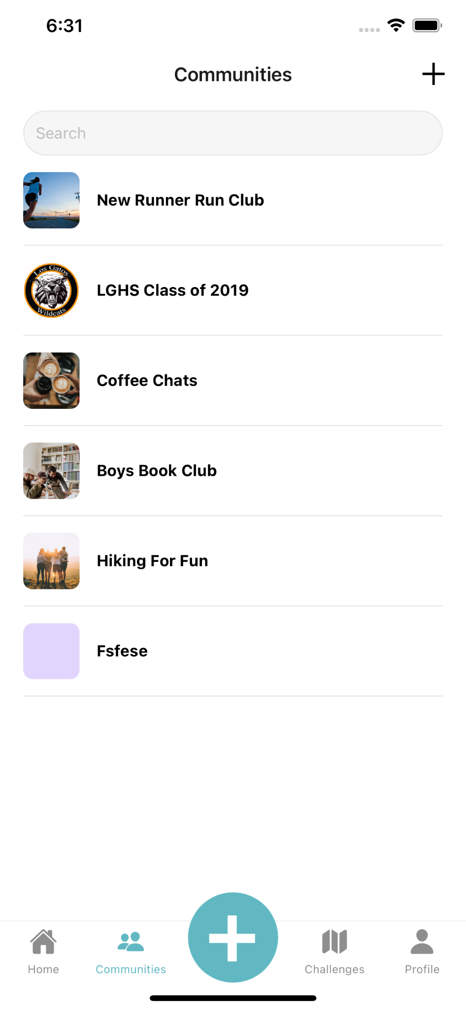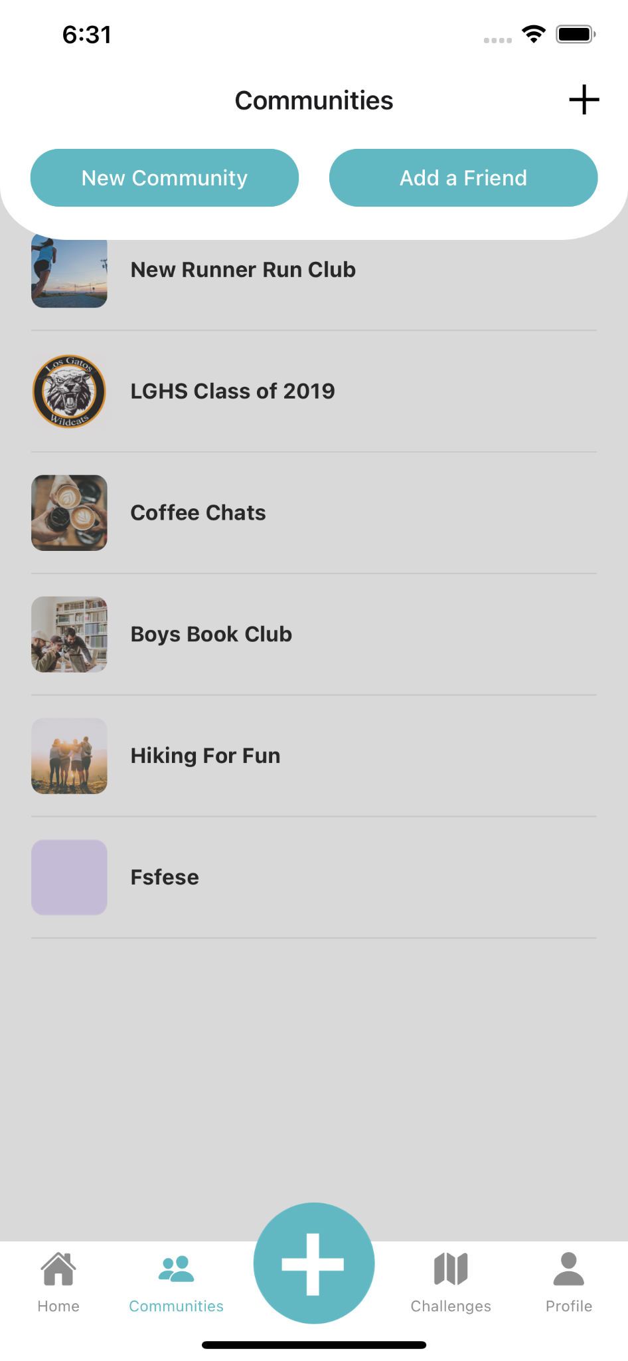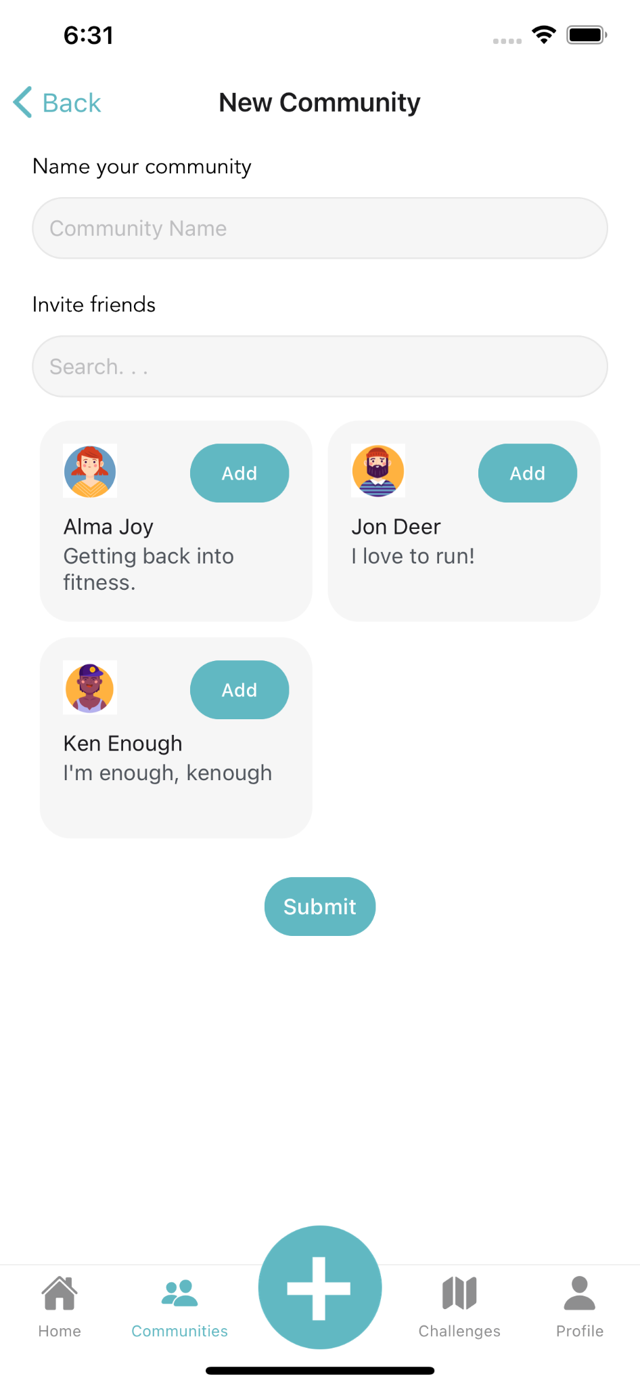

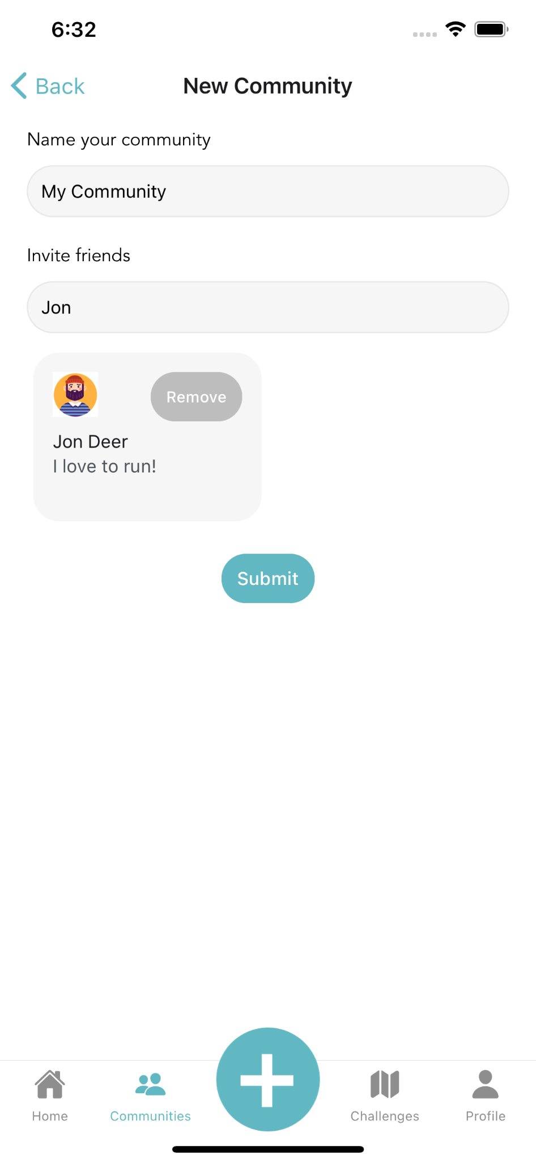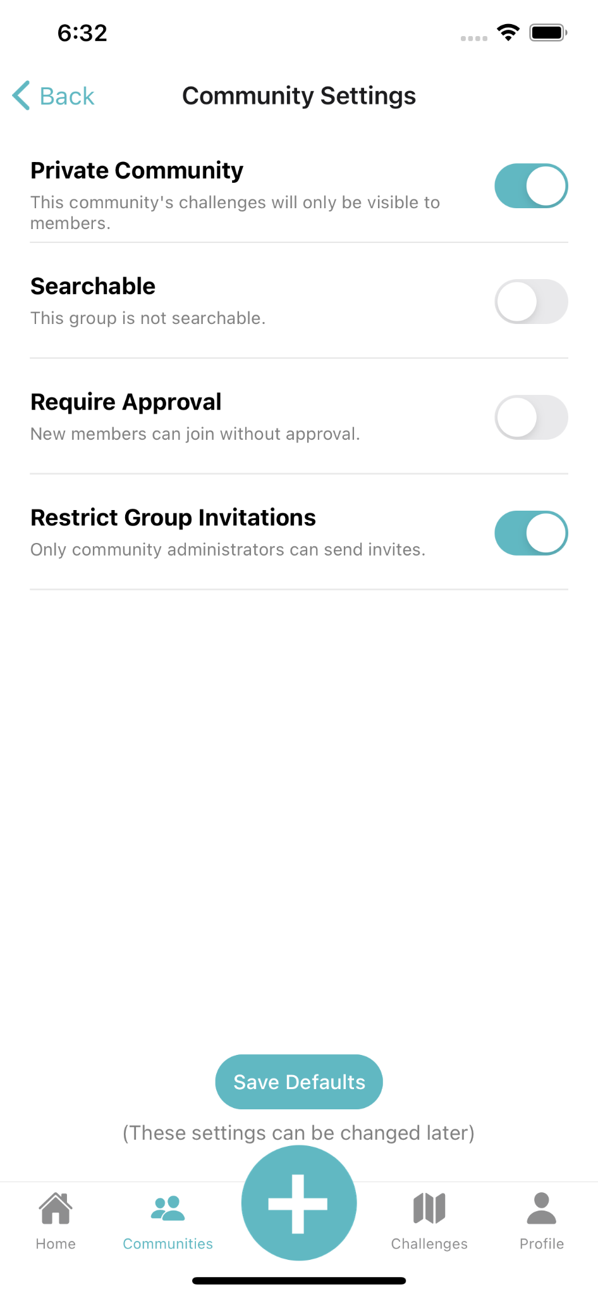
Bonus: Group Challenges Page, Log Book, and Our Backend

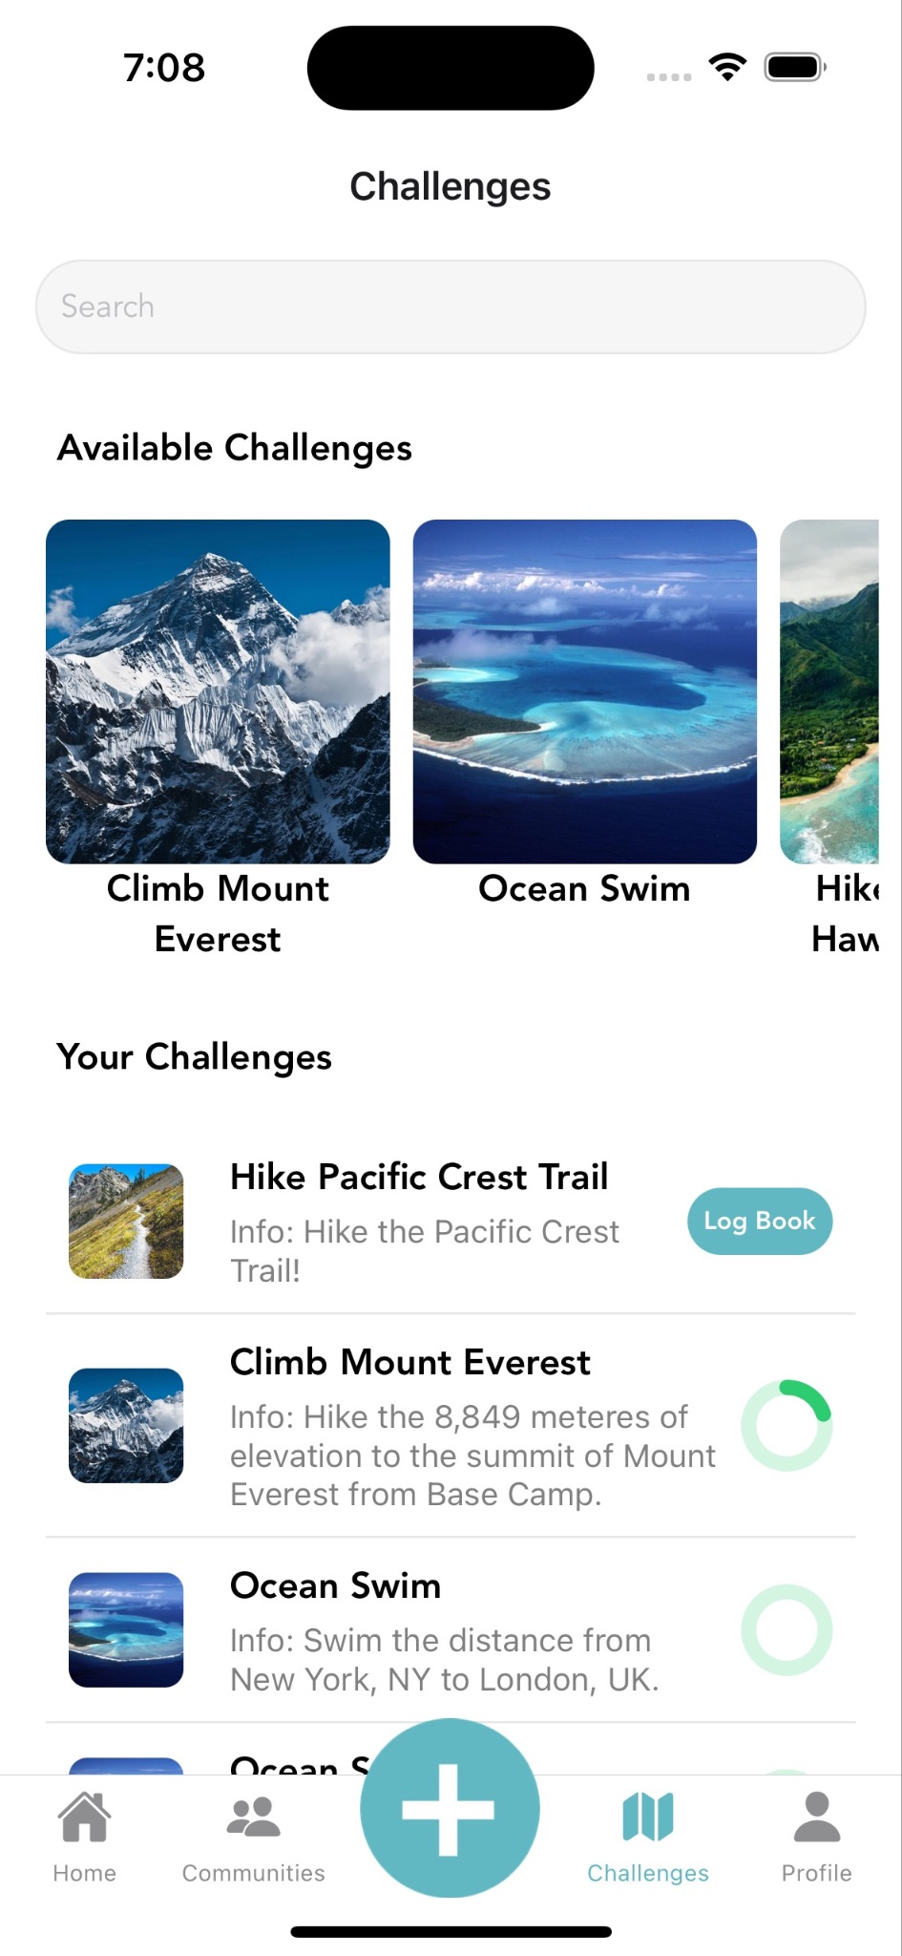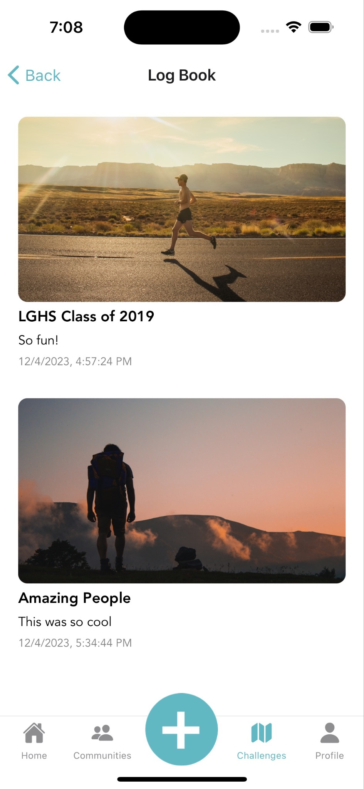

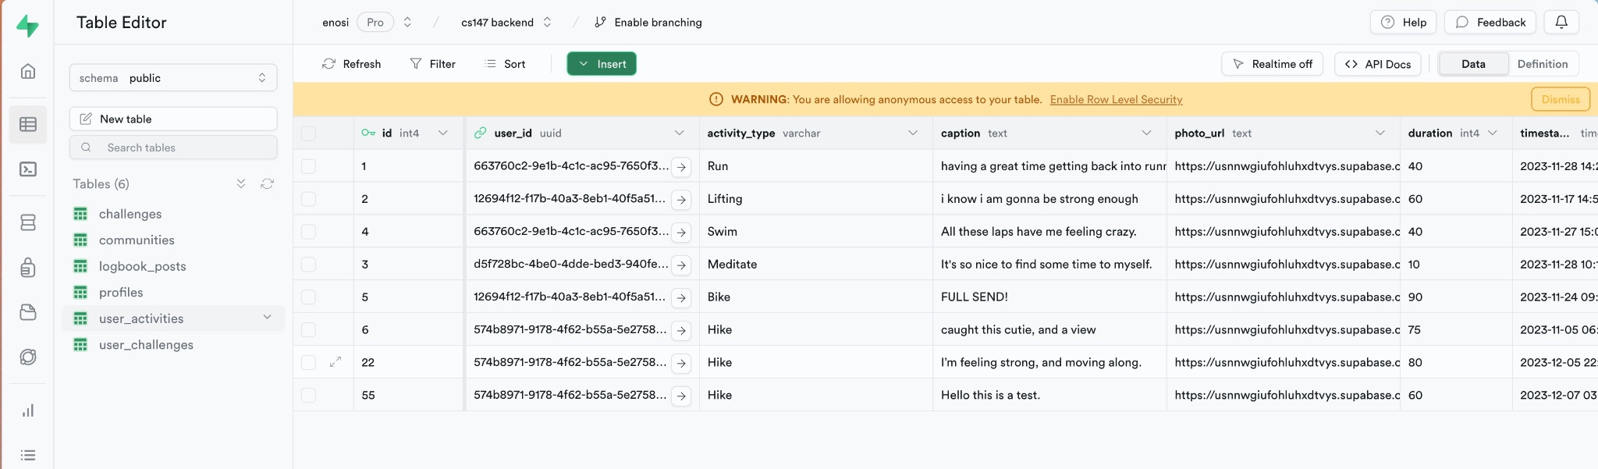

Design evolution visualization(s) and rationale

Simple Task Visualizations

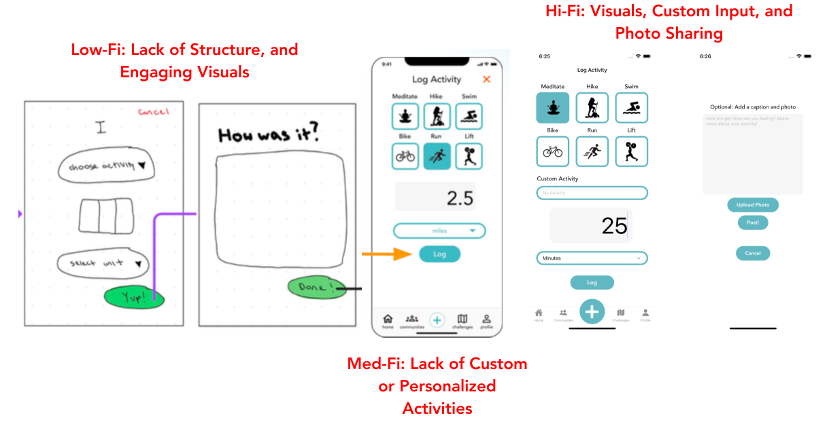
Simple Task Evolution

Low-Fi → Med-Fi
Evaluation Technique: Group Review, User Testing, and Section Feedback

We learned …
Greater survey structure is needed to guide the user to enter the appropriate
information for their activity log, and to maintain consistency amongst all
users’ entries. More prompts are necessary for users to generate a valuable
reflection. More color and visuals would make the UI more engaging.

So we…
Added more structure into how users would log their activities (i.e., provided
placeholder cues and sample answers for text entry boxes), provided them with
sample activities to choose from as well as greater control via text-input to
customize activities, and added visual components (i.e., activity images).

Med-Fi → Hi-Fi
Evaluation Technique: Individual and Group Heuristic Evaluation

While we did not have any Level 4 HE violations, our Level 3 HE Violations were…
Violation: Confusion over the function of the “+” button at the activity page’s bottom navigation bar. Does it add tasks, friends, or communities?

Fix: We chose not to fix this because user-testing proved it was intuitive for many users, and it is a learnable experience.

Violation: Confusion over whether activity was logged

Fix: Added a confirmation modal pop-up for successful activity log

Violation: Logbook and Activity Log have contrasting functions, but the same UI which makes the flow unintuitive for users

Fix: We chose not to fix this because we wanted to maintain consistent UI standards and brand guide presence across pages.

Violation: Lack of access to the logbook for all users

Fix: We chose not to fix this because the logbook should only be visible to certain users to incentivize shared physical activity progress

Violation: Lack of transparency into shared progress towards group goal

Fix: We added progress trackers on our Challenge pages for goals.
Violation: Exit button is too small

Fix: We decided to eliminate it as it was redundant on our UI.

Violation: Logbook and captions for an activity serve the same function

Fix: We decided not to address this because it is a misunderstanding of our system.

Violation: Lack of contrast between placeholder text and text entry box

Fix: We increased contrast to improve readability.

Medium Task Visualizations
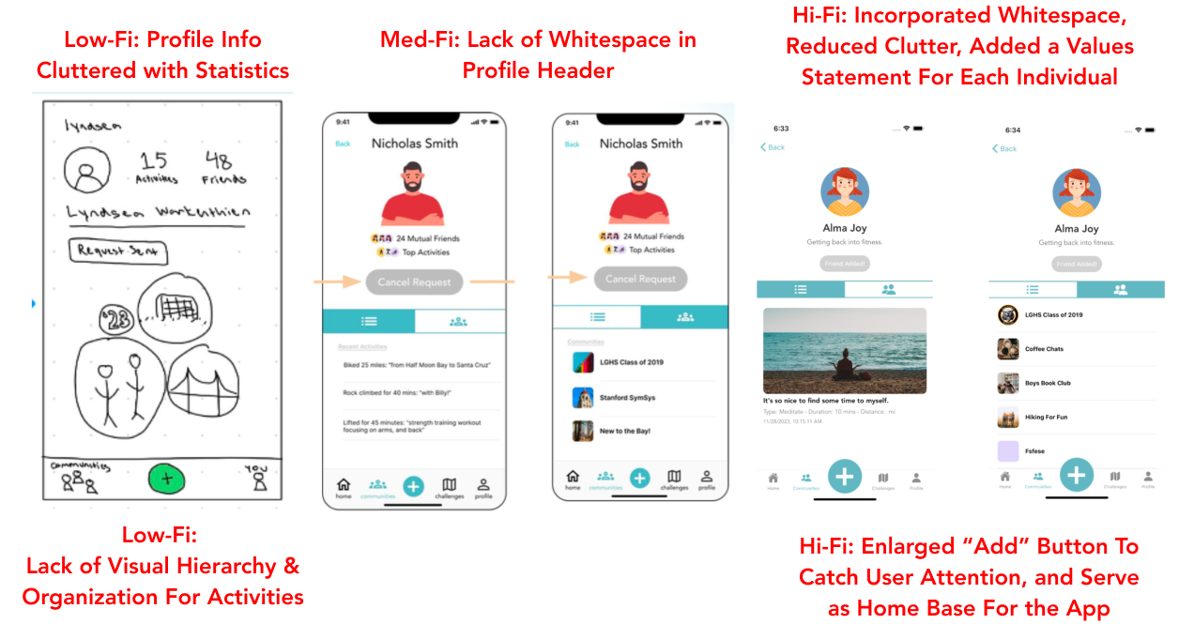

Medium Task Evolution

Low-Fi → Med-Fi
Evaluation Technique: Group Review, User Testing, and Section Feedback

We learned …
More whitespace and breathing room is needed for the Profile page when
viewing another prospective friend. The low-fi prototype contained a lot of
statistics that were relatively irrelevant to the decision process behind whether
one should add a friend. Further, there was no way to cancel a request.
So we…
Made it possible for user to both send friend requests and cancel them from the
same UI. We simplified the UI by removing the statistics, and adding more
Information aiding to the decision process (namely, mutual friends and top
activities that are shared between both users). We also created a toggle menu,
to boost informational value that can drive engagement (i.e.,
recent activities, and shared communities).

Med-Fi → Hi-Fi
Evaluation Technique: Individual and Group Heuristic Evaluation

While we did not have any Level 4 HE violations, our Level 3 HE Violations were…
Violation: Clicking on the grayed-out “Submit” button on this page sends you to Nicholas’ friend-requested page. While I think that this is a bug, it should certainly be fixed.

Fix: We fixed this by making sure all grayed out buttons on the UI were not clickable, and would not navigate to other pages.

Violation: After issuing a friend request, there does not appear to be anywhere one can go to see what the status of that request is or which requests have issued in the past

Fix: We chose not to address this because the button clearly communicates the status of the request (i.e., whether they have been added or not)

Complex Task Visualizations

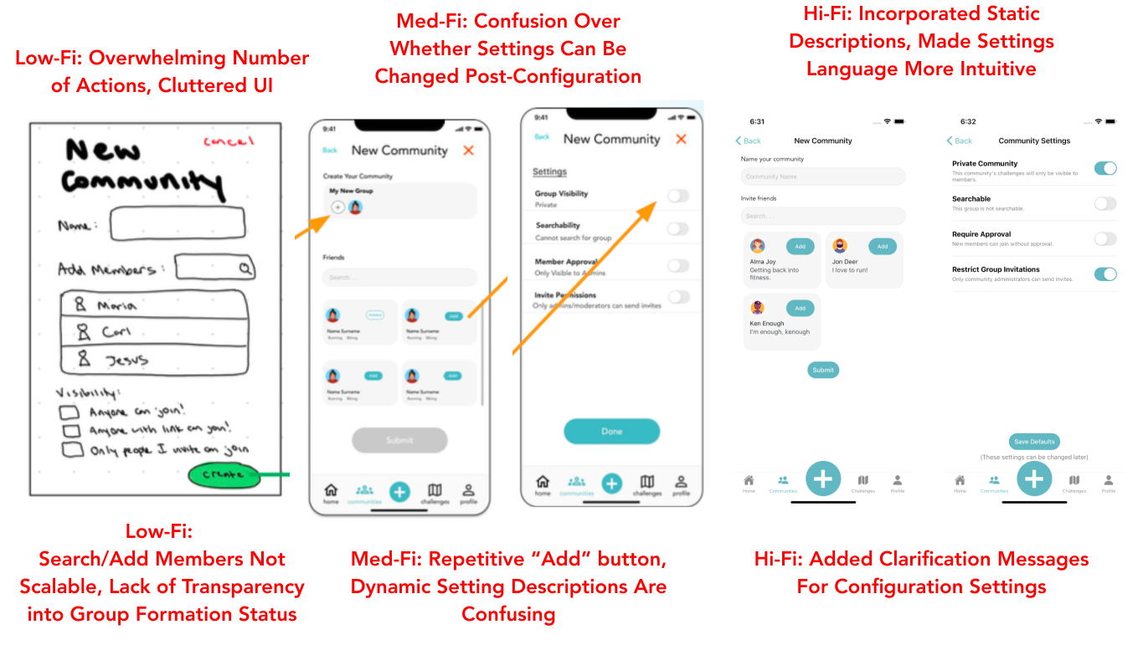

Complex Task Evolution

Low-Fi → Med-Fi
Evaluation Technique: Group Review, User Testing, and Section Feedback
We learned …
The UI for group creation was very cluttered. By squeezing in both the actions of searching/choosing group users and configuring settings, the end result is a UI that overwhelms users with all of the actions they need to take. Further, the box that included users people can choose from did not have any indication of scrollability, and would be difficult to scale well from a design perspective when there are lots of users on the platform.
So we…
Separated the Add Users to Group process and the System Settings into two
distinct pages. We also completely changed the interaction design of the group creation process, specifically when people add users to their groups. By creating small user blocks that highlight the username, profile picture, and ability to add, the interaction is much more visual and fun for users.

Med-Fi → Hi-Fi
Evaluation Technique: Individual and Group Heuristic Evaluation

Our Level 4 HE violations were…
Violation: Grey “submit” button redirects to a separate, non-related page

Fix: We fixed this by ensuring all grayed out buttons are not clickable, or lead to navigation issues.

Our Level 3 HE Violations were…
Violation: The “New Community” screen requires pressing a “+” button to access “Add” buttons that are already displayed.

Fix: We fixed this by removing the redundant “Add” buttons.

Violation: Dynamic descriptions cause confusion about the system status.

Fix: We fixed this by standardizing the language under each category so they are static, to isolate the “yes/no” mental model expectation.

Violation: The settings page is text-heavy and unclear.

Fix: We fixed this by being more concise in the settings page.

Violation: No indication of how many people are needed to form a community.

Fix: We fixed this by ensuring it leads to an error, if enough people are not met in the group creation process.

Values in design

Our design values are: Inclusion, Community, Wellness, Accountability, Individuality, and Privacy. Examples of how such values are embedded in our design features include:
- We ensure the inclusion of users who choose to complete relatively niche physical activities (i.e., skiing, horse-riding, physical therapy, etc) by specifically giving them the option to input custom physical activities.
- We provide the ability for members to build a community from scratch, specifically forming a shared group over a specific common shared interest and lifestyle transition.
- We build a log book, where users can reflect on their own wellness journeys and that of others by reading up on places community members have visited, and how they felt accomplishing their physical activity goals.
- We promote accountability by incentivizing users with a shared group goal in the communities that they are a part of. Having a shared goal, where your contribution matters, makes it a team effort such that other members are more inclined to check in with you!
- We ensure individuality by building out a robust profile page, where users can customize the groups they are a part of, showcase their own top/preferred activities, and put a face to their profile. We allow users to have profile pictures, and to customize their profile page.
- We provide privacy by ensuring our backend is secured, has the appropriate encryptions, and anonymizes sensitive user information from any third-party hacking.
Finding the right balance between design values required extreme user testing,
ongoing user feedback, and evaluating tradeoffs with our MVP. We conducted A/B
testing to arrive at the right balance in between design tensions.
- Inclusivity vs. Individuality: While building an inclusive community, specific individual preferences may not be represented → We solve this by providing visibility into individual experiences, emotions, and feelings across members from all communities who accomplish the same group goal (as a part of the Log Book).
- Community vs. Privacy: Building community requires one to put themselves out there, and share individual life experiences which may be private → We provide users with the ability to specifically add or cancel friend requests and selectively opt into the groups they want to join/create, so they retain control over their social network
- Wellness vs. Accountability: Strict accountability may have adverse effects on one’s own wellness if they aren’t aware of their limitations → Not yet implemented as we have to analyze how users will behaviorally act in a group dynamic. We intend to onboard at least 5-6 users in the same community, and will learn from their interactions as well as survey their interaction experiences. Future development work includes a weekly wellness check-in to strike an initial baseline balance.

Final prototype implementation

Tools used; pros and cons of these tools

Tools we used include React Native, Github, Expo, Supabase (Open Source Firebase Alternative), and VS Code.

Pros:
- Easy simulation of various device screens via Expo
- VSCode makes it easy for file organization and synchronization
- Github allows for version control and cross-team collaboration
- React Native allows for simple development for cross-platform apps
- Supabase has a minimal learning curve, as it is primarily GUI-driven in the browser; easy to quickly push and deploy changes

Cons:
- React Native has a steep learning curve, for beginner users
- Frequent merge conflicts or issues on Github with team members
- Compatibility of distinct versions of React Native and dependency issues, led to interruptions in workflow between team members
- Implementing a backend in Supabase proved difficult due to the limited availability of particular developer integrations

Wizard of Oz and hard coded techniques

There are no Wizard of Oz features in our application, and minimal hard coded features. Instead, we have implemented a comprehensive mobile and web backend in Supabase which captures real-time user data and is responsive with the UI to ensure an optimal, seamless user experience.
Key information that we collect from the user includes their username, password,
profile picture, name, physical activity logs/performance, and log book entries. Such information is stored in our database, and available for the user every time they log into the application.

The only hard coded values in our application are the basic activities users can complete (i.e, run, lift, hike, etc),, placeholder text for text entry boxes (i.e., an optional comment), and the general UI layout (i.e., how the entries in the log book appear).

Reflection & next steps

Reflection

As we built Enosi, our team always kept our mission at the forefront of all of our design and engineering work. Namely, to build a platform that empowers people undergoing lifestyle transitions to collectively pursue their physical and mental well-being. Enosi is an application people can turn to to better themselves, and to find the community and support they need to ensure such a pursuit is successful.

Our most significant takeaway from the quarter is the scaffolding required for approaching a large-scale technical design project. Before taking CS147, there wasn’t a clear picture of what processes exist to bring a large design project or application into existence. With this course, we learned various different types of prototyping at multiple levels, which effectively build on top of one another via rapid prototyping/iteration to come together to a larger than life product.

Through this experience of design, ideation, prototyping, and building along with key strategies such as diverging to create space of possibilities or converging to narrow in on the right ideas, our group learned how to keep the user in mind though the design process and use systematic processes to integrate their feedback from start to finish.

Future Work

If we had more time in the future, we would love to return to our users that we interviewed at the beginning and conduct additional user interview research to gauge their feedback and experience using the application. Additionally, we would love to run a few A/B tests with said group as well as new users to gauge the effectiveness of certain features (i.e., enlarging the “Add” button on the Home page, or adding “Progress Trackers'' on the Challenge page).

We would also love to focus more on secondary task flows (i.e., outside of the simple, medium, complex task requirements for the class) such as the Challenge Page or Log Book that are not required yet critical to the user experience and highly important for driving key metrics such as onboarding, engagement, and retention (and also push the needle towards our overall mission). Key features we may add include visibility into exactly who in a shared community contributed to a group goal, direct messaging chat channels between community members, and group chats in the shared communities.

